˘APPLICATION PROGRAMMING LANGUAGE=
Soa= application build using independent services communicating using protocols like http ,soap is called as soa.

API TESTING=
- EVERY APPLICATION CONSITS OF FRONTEND AND BACKEND .
- FRONTEND WHICH IS VISIBLE TO THE USER LIKE TF, RADIO BUTTON, CHECKBOX , RATIO BUTTION.
- BACKEND CONSITS OF CODE WRITTEN BY THE DEVELOPER OR SOURCE CODE , DATABASE .
- IN FRONTEND MANUEL TESTING AND AUTOMATION TESTING IS PERFORMED.
- IN THE BACKEND API TESTING FALLS INTO ACTION.

TYPES OF APPLICATION CLASSIFIED INTO 2 TYPES=
- 1 STANDALONE APPLICATION.
- 2 CLIENT SERVER APPLICATION
- a.CLIENT SERVER APPLICATION
- b.WEB APPLICATION = 1. STATIC WEB APPLICATION 2. DYNAMIC WEB APPLICATION.

1 STANDALONE APPLICATION=
- NO INTERNET IS REQUIRED.
- DOESN’T REQUIRE ANY EXTERNAL SERVER.
- NO DATABASE IS REQUIRED.
- INSTALLATION IS REQUIRED .
- SINGLE USER CAN USE IN A SYSTEM.
- EXAMPLE = BROWSER , NOTEPAD , CALCULATOR ,PAINT ETC..,

BROWSER IS A STANDALONE APPLICATION=
- WE CAN OPEN PDF IN BROWSER WITHOUT INTERNET.
- ALL THE PORT NUMBER / LOCALHOST WE CAN AXCESS.
- IF WE WANT TO AXCESS ANY EXTERNALL APPLICATION INTERNET IS REQUIRED.
- ANY APPLICATION INSTALLED LOCALY / ANY OFFLINE DOCUMENT OFFLINE PDF CAN STILL OPEN APPLICATION WITH BROWSER.
- WRITING HTML CODE WITHOUT INTERNET AXCESS.

2 CLIENT SERVER APPLICATION=
REQUEST
WHATSAPP SERVER

SOURCE CODE
USER A CLIENT SERVER
RESPONSE
USER B CLIENT SERVER

- V SENT VV DELIVERED VV RED BY THE OTHER USER
EXAMPLE = IN FRONTEND-
- USER A WANTS TO SEND A MESSAGE TO USER B – LAUNCH APPLICATION , SELECT CONTACT , SEND BUTTON , USER B WILL RECIVE THAT MESSAGE AND USER B WILL RESPOND.
EXAMPLE = IN BACKEND
- SRS IS GIVEN TO 2 TEAMS DVELOPER TEAM AND TESTING TEAM.
- EVERY CODE/SOURCE CODE WRITTEN BY THE DEVELOPER IN ORDER TO DEVELOP APPLICATION THAT IS STORED IN THE SERVER.
- DATA IS STORED IN THE DATABASE.
- CLIENT SOFTWARE WHATSAPP , FACEBOOK , INSTA ETC..,(MOBILE)
- WITHOUT INSTALLING CLIENT IT IS NOT POSSIBLE TO USE CLIENT APPLICATION.
- IN A CLIENT SERVER APPLICATION CLIENT IS MANDETORY.
USER A SENDS A MESSAGE, REQUEST GOES TO WHATSAPP SERVER , SERVER WILL PROCESS AND ANALYZE THE REQUEST AND SENDS RESPONSE TO USER B AND SERVER PROVIDE RESPONSE TO USER A.

3 WEB APPLICATION= SERVICE ORIENTED ARCHTECTURE (SOA ) 3 TIER ARCH
- ANY APPLICATION AXCESSING WITH BROWSER WE CALL IT HAS WEB APPLICATION .
- WEB APPLICATION FALLS INTO THE CLIENT SERVER APPLICATION .
- BROWSER IT SELF ACT AS A CLIENT .
- IN THE BROWSER WE ENTER THE URL NOTHING BUT THE ADRESS OF THE APPLICATION SERVER.
- REQUEST WILL SEND TO THE SERVER , SERVER WILL PROCESS AND GIVE RESPONSE TO SAME BRWOSER.
- IN CLIENT SERVER APPLICATION CLIENT IS MANDETORY .
- FOR A WEBAPPLICATION BROWSER IS A MANDETORY.

WEB APPLICATION ARCHITECTURE / LAYERS=
- WEB APPLICATION ALWAYS START WITH 2 TIER ARCHITECTURE.
- 2 TIER ARCHTECTURE JUST AS FRONTEND AND BACKEND.

WE ARE DEALING WITH THE 3 TIER ARCHTECTURE=
- WE HAVE 3 COMPONENTS = BROWSER , SERVER , DATABASE SEPARATELY.

SERVER HAS 2 DIFFERENT PARTS=
- 1 WEB SERVER = PRESENTATION LAYER , FRONTEND
- 2 APP SERVER /WEB APPLICATION= BUSINESS LAYER , MIDLEWARE , BACKEND
- INSIDE APP SERVER / WEB APPLICATION WE HAVE SOURCE CODE.
- EXAMPLE = home.java , profile.java , message.java etc..,
- INSIDE WEBSERVER WE HAVE HTML FILES .
- JAVA TELLS US HOW THE APPLICATION SHOULD WORK LIKE
- HTML TELLS US HOW THE APPLICATION LOOK LIKE.
- HTML FRONTEND , PROGRAMMING LANGUAGE BACKEND.

= BROWSER CANNOT INTERACT WITH APPSERVER.
- BROWSER CAN ONLY INTERACT WITH WEB SERVER =
- BROWSER AND APPSERVER INTERACTION NOT POSSIBLE AND WEBSERVER PROVIDE RESPONSE.

- WEBSERVER SEND REQUEST TO APP SERVER AND IT WILL EXECUTE THE SOURCE CODE
- AND APP SERVER COMMUNICATE WITH DATABASE AND CHECK FOR THE CREDENTIALS .
- APP SERVER EXECUTE AND SEND DATA BACK TO THE WEB SERVER AND SENDS TO BROWSER.

AUTHENTICATION=
- NOTHING BUT VERIFIYING USER CREDENTIALS AUTHENTICATION.
- AUTHENTICATION TAKES ONLY ONCE AT THE TIME OF LOGING INTO THE APPLICATION.

- SOURCE CODE IS ALSO CALLED AS BUSSINESS LOGIC OR WEB RESOURCE.
- FOR APP SERVER WE WILL CALL IT HAS BUSINESS LAYER .
- FOR WEB SERVER WE WILL CALL IT HAS PRESENTATION LAYER.
- FOR DATABASE DATABASE LAYER TOTAL 3 LAYERS
WEB SERVER / PRESENTATION LAYER

LOGIN HOME PROFILE ERROR

.HTML .HTML .HTML .HTML

LOGIN HOME PROFILE ERROR

.JAVA .JAVA .JAVA .JAVA
HTTP://URL
BROWSER
HTML, CSS ,JS
http request

-
http response
DB LAYER
J
D
B
C
API
APP SERVER / WEB APPLICATION / MIDDLE LAYER / BACKENT TESITNG / API TESTING /BUSINESS LAYER
DB LAYER

BROWSER = |

THE LANGUAGES UNDERSTANDABLE BY THE BROWSER ARE= IF PYTHON PY-ODBC
- 1 HTML , 2 CSS , 3 JAVASCRIPT.
- SINCE BROWSER MAKES USE OF HTTP PROTOCOL ANY REQUEST AND RESPONSE IS CALLED AS HTTP REQUEST AND HTTP RESPONSE.
- HTTP = HYPER TEXT TRANSFER PROTOCOL

1 BROWSER=
- BROWSER IS A STANDALONE APPLICATION THAT IS USED TO AXCESS ANY WEB APPLICATION OVER THE NETWORK VIA URL.
- REQUIRE INTERNET OVER THE NETWORK.
- THE BROWSER UNDERSTAND ONLY HTML , CSS AND JS AND HENCE IT ALWAYS CREATE HTTP REQUEST AND INTERPRET HTTP RESPONSE GIVEN BY THE WEB SERVER.
- THE BROWSER IS THE ONLY WAY TO AXCESS THE WEB APPLICATION.
- THE BROWSER ALWAYS SEND / RECIVE THE REQUEST VIA HTTP .
- EXAMPLE = CHROME , BRAVE , SAFARI , FIREFOX , OPERA , EDGE ETC..,

2 WEB SERVER=
EXAMPLE = HOTEL – SERVER – CHEF – SERVER – CUSTOMER
- WEB SERVER AS NAME IMPLIES IT “ SERVER REQUEST TO A BROWSER “ , IT HELP BOTH CLINET BROWSER AND WEB APPLICATION / APP SERVER TO INTERACT WITH EACH OTHER.
- IT RECIVE THE REQUEST FROM THE BROWSER , COMMUNICATE WITH WEB APPLICATION AND PROVIDES A RESPONSE BACK TO THE BROWSER.
- EVERY APP SERVER ( WA) IS UNDER THE CONTROL OF THE WEB SERVER.
- EXAMPLE = APACHE TOMCAT , MICROSOFT IIS ETC..,
- IT IS A PRESENTATION LAYER.

3 APP SERVER / WEB APPLICATION=
- IT IS A COLLECTION OF WEB RESOURCES IS CALLED AS APP SERVER.
- IT IS A BUSINESS LAYER , MIDDLE WARE , BACKEND , API TESTING
- EXAMPLE = APACHE JBOSS , IBM WEB SPHERE , ORACLE WEB LOGIN , ORACLE GLASS FISH ETC..,

THERE ARE 2 TYPES OF WEB RESOURCES=
- 1 STATIC WEB RESOURCES EX = TAG – COKE – SERVER – FRIDGE - GIVE
- 2 DYNAMIC WEB RESOURCE. EX= TAJ – FRICE – SERVER – CHEF – PREPARE

1 STATIC WEB RESOURCE=
- RESPONSE PRESENT WITHIN THE WEB APPLICATION BEFORE THE REQUEST IS SENT.
- EXAMPLE = WIKIPEDIA , ONLINE DICITONARY , DOCUMENTATION WEBSITE.
- WHEN THE WEB APPLICATION IS A COLLECTION OF STATIC WEB RESOURCES THEN IT IS CALLED AS STATIC WEB APPLICATION.
NOTE= STATIC WEBAPPLICATION CAN BE DEVELOPED USING HTML ALONE.
STATIC WEB
RESOURCE
STATIC
STATIC

STATIC DYNAMIC WEB
RESOURCE
STATICS
STATIC
DYNAMIC
STATIC
STATIC
STATIC

2 DYNAMIC WEB RESOURCE=
- EXAMPLE= INTERNET BANKING TRANSACTION 1000 AMOUNT UPI ID AMOUNT TRANSFER ENTER AMOUNT 10,000 DEDUCTED DEVELOPER CAN’T WRITE CODE TO , INORDER TO SEND 10,000 TOMMORROW 25000 IT IS DYNAMIC WEB RESOURCE AMOUNT GETS DEDUCTED.
- RESPONSE BIENG GENERATED AT THE TIME OF THE REQUEST.
- EXAMPLE , INTERNET BANKING , GMAIL ..,
- EVEN IF THE APPLICATION CONSITS OF 1 DYNAMIC WEB RESOURCE WE CALL IT HAS DYNAMIC WEB APPLICATION.
NOTE = SERLET OR JSP OR SPRING BOOT IS MANDETORY TO DEVELOP A DYNAMIC WEB APPLICATION.

3 DATABASE=
- A DATABASE IS A PLACE OR A MEDIUM IN WHICH WE STORE THE DATA IN AN ORGANIZED MANNER.
- EX= MYSQL , MSSQL , ORACLE 10G/11G , DB2 , SYBASE , NOSQL , MONGO DB , CASANDRA.

- ENTIRE APP SERVER DEVELOPED WITH THE HELP OF JAVA .
- ALL THE DATA IN THE DATABASE IS STORED IN TABULAR FORMAT.
- DATABASE DOESN’T UNDERSTAND JAVA WE HAVE LANGUAGE BARIER THEY DON’T UNDERSTAND EACH OTHER.
- WE HAVE A MEDIATER BETWEEN APP SERVER AND THE DATABASE SO WE HAVE JDBC API FOR PYTHON PY-ODBC.

- WEB SERVER IS DEVELOPED USING HTML , APP SERVER DEVELOPED USING JAVA , THEY DON’T INTERACTABLE WITH EACH OTHER HENCE WE NEED A MEDIATER SO WE HAVE SERVLET.
- SERVLET ACTS AS MEDIATOR BETWEEN APP SERVER AND WEB SERVER.

JDBC API=
- JDBC = JAVA DATABASE CONNECTIVITY IS A COLLECTION OF JAVA API’S WHICH IS USED TO CONNECT THE DATABASE TO THE JAVA PROGRAMME.
- USING JDBC , WE CAN STORE AND FETCH THE DATA FROM THE DATABASE.

SERVLET=
- SERVLET IS A COLLECTION OF J2EE API , IT IS USED TO DEVELOP DYNAMIC WEB APPLICATION.
- J2EE = JAVA ENTERPRISE EDITION IT IS ADVANCE JAVA.
- SERVLET ALSO CONTAINS A WEB.XML FILE , WHICH IS USED FOR MAPPING BETWEEN WEBSERVER AND APPSERVER.
- WEB.XML FILE HELPS TO MAP THE DATA BETWEEN WEBSERVER AND APP SERVER.

WEB URL=
- URL – UNIFORM RESOURCE LOCATOR , UNIVERSAL RESOURCE LOCATOR , UNIFIED RESOURCE LOCATOR.
- IT IS USED TO UNIQULY IDENTIFY THE SPECIFIC WEB RESOURCE WITHIN THE WEB APPLICATION .
- EVERY WEB APPLICATION SHOULD HAVE ITS UNIQUE ADDRESS IN THE FORM OF A URL.
- URL IS THE ONE AND ONLY WAY TO ACCESS WEB APPLICATION VIA BROWSER .

WHO EVER DEVELOPED THE APPLICATION WILL HAVE TO FOLLOW THE SYNTAX=
- PROTOCOL :// DOMAINNAME : PROT NUMBER / RESOURCE PATH ? QUERY STRING # FRAGMENT ID.

PROTOCOL=
A protocol is essentially a set of rules or standards that define how data is transmitted and recived between devices or systems so thay can comunicate properly
- WHEN ONE APPLICATION WANTS TO COMMUNICATE WITH ANOTHER APPLICATIOIN , THERE NEEDS TO BE A COMMON LANGUAGE THAT BOTH APPLICATIONS UNDERSTAND EACH OTHER , HENCE WE USE PROTOCOL.
- BETWEEN THE BROWSER AND SERVER HTTP ACTING AS COMMON LANGUAGE
- THE PROTOCOL IS A COMMON LANGUAGE WHERE 2 APPLICATIONS EXCHANGE INFORMATION WITH EACH OTHER.
- IT IS A SET OF RULES AND INSTRUCTIONS .
- PROTOCOL WILL BE TAKEN AUTOMATICALLY .
- WHEN EVER WE USE A WEB APPLICATION USE OF PROTOCOL IS OPTIONAL THING .
- HTTPS= HYPER TEXT PROTOCOL SECURED ( LEFT SYMBOL LOCK).
- THE BROWSER ALWAYS SENDS A REQUEST AND RECIVE A REQUEST A RESPONSE VIA HTTP PROTOCOL HENCE IT IS CALLED AS HTTP REQUEST AND HTTP RESPONSE.
- ITS OPTIONAL INFORMATION AND CASE SENSITIVE.

TYPES OF PROTOCOL=
- 1 HTTP 2 HTTPS 3 FTP 4 SMTP
- HTTP =NOT SECURE , DATA VISIBLE.
- HTTPS = SECURED , DATA ENCRYPTED.
- FTP = FILE TRANSFER PROTOCOL – TRANSFER COMPUTER FILES FROM SERVER TO CLIENT.
- SMTP = SIMPLE MAIL TRANSFER PROTOCOL – SENDING AND RECIVING EMAIL MESSAGE OVER INTERNET.

DOMAIN NAME= ( CMD = PING WWW.FLIPKART.COM ) FOR IP ADRESS
- IT IS USED TO UNIQULY IDENTIFY THE SPECIFIC COMPUTER / SERVER WITHIN THE NETWORK IN WHICH WEB APPLICATION IS PRESENT.
- A DOMAIN NAME MIGHT BE A COMPUTER NAME OR IP ADRESS .
- ITS MANDETORY INFORMATION.
- WITH THE HELP OF IP ADRESS WE CAN AXCESS.

- WHENEVER AN APPLICATION IS UNDER DEVELOPMENT EVERY APPLICATION WILL NOT HAVE A NAME DECIDED IN THE INITIAL STAGE 1ST WE WILL USE IP ADRESS THEN WE WILL DECIDE NAME.

- EXAMPLE = WWW. AMAZON .COM COMMERCIAL , WWW. SUB DOMAIN
- .ORG ORGANIZATION
- .EDU EDUCATION
- GOV.IN GOVERNAMENT
- CO.IN COMMERCIAL COUNTRY CODE INDIA
- CO.UK IS USED IN THE UK

PORT NUMBER=
- PORT NUMBER START WITH COLUN .
- USED TO UNIQLY IDENTIFY THE SPECIFIC SOFTWARE APPLICATION WITHIN THE COMPUTER.
- IT IS OPTIONAL INFORMATION IN THE WEB URL.
THE BELOW TABLE SPECIFY THE DEFALUT PORT NUMBER
WEB SERVER | TOMCAT | JBOSS | WEBLOGIC
HTTP | LOCALHOST:8080 | 9990 | 7001
HTTPS | 8443 | 443 | 456

RESOURCE PATH=
- USED TO UNIQLY IDENTIFY THE SPECIFIC WEB RESOURCES WITHIN THE APPLICATION SERVER ( WEB APPLICATION ).
- HTTP://LOCALHOST:8080/ INDEX.HTML
- HTTP://LOCALHOST:8080/ LOGIN

QUERY STRING =
- IT IS ONE OF THE PARAMETER PASSED IN THE URL WHICH IS USED TO SPECIFIY / FILTER A CONDITION .
- QUERY STRING ALWAYS BEGIN WITH ? (QUESTION MARK)
- THE QUERY STRING/DATA ALWAYS WRITTEN IN NAME = VALUE PAIR .
- WE CAN HAVE ANY NUMBER OF NAME VALUE PAIR SEPARATED BY & OR TO SEGRAGATE EACH NAME VALUE PAIR IN & SYMBOL .
- DECLARED Q =JUST TO INDICATE IT IS A QUERY STRING.

FRAGMENT ID=
- USED TO UNIQLY IDENTIFY THE SPECIFIC FRAGMENT / SECTION WITHIN THE WEBPAGE.
- FRAGMENT ID SHOULD ALWAYS BEGIN WITH # .
- EXAMPLE #INDEX , # DRAFTS , #SENT

TYPES OF LANGUAGE=
Soap ws response
Soap ws request
xml
xml
http response
http request
.py
.py
.xml
.xml

REQUESTER
.java
.java
.xml
.xml
JAXB
CARD NO :HSBC 123 CVV: 123

Parser tool
PRGRAMMING LANGUAGE | SCRIPTING LANGUAGE | OTHER LANGUAGE
C, C++ , C# , JAVA , SWIFT | PYTHON , VISUAL BASICS , JAVASCRIPT , SHELL SCRIPT , PHP , RUBY | XML , XSD , DTD , JSON , HTML
DEVELOPMENT OF SOFTWARE | USED FOR VALIDATION , GIVING CONDITION FOR WEB ELEMENT
 | EXAMPLE = SHOULD ACCEPT ONLY 6 CHARACTERS

-----------------------------amazon----------------------------------------------HSBC----------
URL PAYMENT SUCESS

EXAMPLE=
IN AMAZON WHEN WE MAKING CARD PAYMENT IT WILL ASK FOR CARD NO AND CVV SUBMIT , REQUEST GOES TO THE AMAZON SERVER IT WILL VERIFY AND SEND IT TO THE CARD BANK SERVER AND IT SEND TO DB , IT WILL SEND OTP FOR SECURITY REASON , GIVING PERMISSION TO THE BANK TO TRANSFER AMOUNT , BANK SERVER SEND RESPONSE TO AMAZON , AMAZON SEND TO BROWSER.

EXAMPLE=
- AMAZON DEVELOPED IN JAVA , HSBC DEVELOPED IN PYTHON COMMUNICATION BETWEEN THOSE 2 APPLICATION IS NOT POSSIBLE ,
- ALL THE JAVA FORMAT IS CONVERTED INTO XML FORMAT USING TOOL JAXB THIS TOOL IS A PARSER TOOL.
- HSBC DATA WILL BE SENT IN XML FORMATE USING REQUESTER IT WILL CONVERT INTO PYTHON GO TO DB FETCH SEND TO HSBC CONVERT TO XML TO JAVA AND GIVE RESPONSE .

PARSER TOOLS=
- PARSER TOOLS ARE THE LANGUAGE SPCIFIC .
- JAXB = USED TO CONVERT JAVA TO XML , XML TO JAVA.
- REQUESTER = USED TO CONVERT XML TO PYTHON , PYTHON TO XML.

XML=
- XML IS USED TO STORE AND TRANSFER THE DATA BETWEEN 2 APPLICATIONS.
- IF ONE SERVER IS SENDING A REQUEST TO ANOTHER SERVER IN THE FORM OF XML IT IS CALLED AS SOAP WEB REQUEST.
- IF ONE SERVER IS RECIVING A REQUEST FROM ANOTHER SERVER IN THE FORM OF XML IT IS CALLD AS SOAP WEB RESPONSE.
- SOAP = SIMPLE OBJECT AXCESS PROTOCOL.

XML=
- XML STADS FOR = EXTENSIBLE MARKUP LANGUAGE (XML).
- XML IS USED TO STORE AND TRANSPORT DATA BETWEEN 2 APPLICATIONS.
- IT IS A COLLECTION OF CUSTOM TAGS / USER DEFINE TAGS.
HTML | XML
IT IS USED TO DESIGN A WEB PAGE. | TO STORE AND TRANSPORT THE DATA
<HEAD > <BODY><DIV><A><INPUT><SPAN>  IT IS COLLECTION OF INBUILT TAGS / PREDEFINED TAG. | WE CAN CREATE WHAT EVER TAG WE WANT  <CAR> <BIKE><PEN><CYCLE>
IT IS NOT CASE SENSITIVE | IT IS CASE SENSITIVE.

- IT IS VERY STRICTLY TYPED LANGUAGE= BECOUSE IF THERE IS A TAG WHICH IS OPEN WE SHOULD MUST CLOSE THE TAG , WE SHOULD USE FORWARD SLASH(/).

XML FOLLOWS TREE STRUCTURE=
- IT INITIALLY START WITH < ROOT > TAG.
- FOLLOWED BY < CHILD > TAG.
- WITHIN CHILD TAG WE CAN HAVE N NUMBER OF < SUBCHILD > TAGS .
- WE CAN HAVE ONLY 1 <ROOT> TAG WHICH IS PARENT OF ALL <CHILD > TAGS .
<root>
<CARDDETAILS>
<CARDNO>HSBC123 </CARDNO>
<CVV>123</123>
</CARDDETAILS>
<child>
<subchild>
</subchild>
</child>
</root>
WHEN IT IS CONVERTED INTO XML IT LOOKS LIKE

- IT IS CASE SENSITIVE .
- XML IS ‘MARKUP LANGUAGE “ AND PLATFORM INDEPENDENT LANGUAGE “ WHICH HELPS TO STORE AND TRANSPORT DATA.
- IF 2 APPLICATION DEVELOPED USING DIFFERENT PROGRAMMING LANGUAGE IN DIFFERENT SYSTEM LIKE MAC , WINDOW WE CAN STILL EXPORT THE DATA SO IT IS PLATFORM INDEPENDENT LANGUAGE.
- WHETER BOTH APPLICATIONS DEVELOPED USING SAME LANGUAGE BUT IT NEEDS TO TRANSPORT THE DATA SO CONVERTING INTO XML IS MUST.
- DIFFERENT APPLICATIONS WHICH ARE DEVELOPED USING DIFFERENT TECHNOLOGYS OR SAME TECHNOLOGYS IT CAN TRANSFER THE DATA AMONG THEM SELVES WITH THE HELP OF XML.

- AS THE NAME IMPLIES ITS AN EXTENSION OF HTML HENCE XML LOOKS SIMILAR TO HTML BUT ITS NOT A HTML.
- XML HAS USER DEFINED COSTOM TAGS.
- CONTENT TYPE OF XML IS “ APPLICATION /XML” OR SYNTAX.

XML ENTITY REFERENCE=
SELECT * FROM EMP  WHERE SAL <10000 | <EMP >  <NAME>  SAL<10000 ( SAME <> TAGS HERE)  </NAME>  </EMP>

- EVERY WHERE WE ARE USING SAME SYMBOL (<>) IT IS GETTING CONFUSED.
- WE ARE NOT ALLOWED TO USE <> SYMBOLS IN XML.
- SOME CHARACTER HAVE A SPECIAL MEANING IN XML .
- IF WE PLACE A CHARACTER LIKE “<” INSIDE AN XML ELEMENT , IT WILL GENERATE AN ERROR BECOUSE IT REPRESENTS THE START OF A NEW ELEMENT
- < MESSAGE > SALARY<1000 </MESSAGE>
- TO AVOID THIS ERROR , WE CAN REPLACE THE “ < “ OPERATOR WITH AN “ENTITY REFERENCE” AS SHOWN BELOW.
- <MESSAGE > SALARY &LT: 1000 </MESSAGE>

THERE ARE 5 PRE – DEFINED ENTITY REFERENCE IN XML=
- 1 &lt; = lesthan , 2 &gt; = greater than , 3 &amp; =ampersand , 4 &apos; = apostraphy , -5 &quot; “qutation mark.

XML ELEMENTS AND ATRIBUTE=
- XML ELEMENTS CONSITS OF THE START TAG AND THE END TAG.
- AN ELEMENT CAN CONTAIN =
- DATA , ATTRIBUTES , OTHER ELEMENTS , ALL OF THE ABOVE.
- XML ATTRIBUTES ARE WRITTEN IN NAME=VALUE WITHIN THE START TAG OF AN ELEMENT .
- ATTRIBUTE CANNOT BE EXPANDED LIKE ELEMENTS .
- ALL THE STATIC DATA WILL BE KEPT IN ATTRIBUTE .
<book id="b101" genre="fiction"> - ATTRIBUTE 1 =1ST ROOT TAG IS ALSO ELEMENT IF NO ATTRIBUTE
<title>The Alchemist</title> - ELEMENT
<author>Paulo Coelho</author> - ELEMENT 3
<price>350</price> - ELEMENT
</book>

XML PARSER=
- JAXB IS A JAVA API HELP US TO CONVERT JAVA OBJECT TO XML AND VICE-VERSA.
- THE PROCESS OF CONVERTING JAVA OBJECT TO XML IS CALLED AS “ MARSHALLING” OR “ SERIALIZATION” .
- THE PROCESS OF CONVERTING XML TO JAVA OBJECT IS CALLED AS “ UNMARSHALLING “ OR DESERIALIZATION”
- 90% OF IT INDUSTRY NOT USING XML.
- THOSE COMPANY NOT DEPENDING ON LATEST TECHNOLOGY MAY USES XML.
- EXAMPLE #INDEX , # DRAFTS , #SENT

----------------------------amazom server---------------------------------------------------------
jackson
URL PAYMENT SUCESS
http request
rest ws request

Parser tool
.json
.java
.json
.py
jsonmodule
Json
rest ws response
.json
.java
http response
.json
.py
. Jso

JSON=
- WHEN WE SENDING THE REQUEST IN FORM OF JSON IT IS CALLED AS REST WSS REQUEST.
- WHEN WE RECIVE THE RESPONSE IN FORM OF JSON IS CALLLED AS REST WSS RESPONSE.
- JSON USED STORE AND TRANSFER DATA BETWEEN 2 APPLICATIONS.
- JACKSON PARSER TOOL IS USED TO CONVERT JAVA TO JSON.
- JSONMODULE IS USED TO CONVERT JSON TO PYTHON.
- XML AND JSON WORKS IN SAME MANNER.

JSON=
- JAVASCRIPT OBJECT NOTATION.
- IT IS USED TO STORE AND TRANSFER DATA BETWEEN 2 APPLICATIONS .
- IT IS VERY LIGHT WEIGHT LANGUAGE .( BECOUSE OF ITS STRUCTURE).
- IN JSON OBJECT CREATION IS MUST OPEN CURLY BRACES{ AND CLOSE CURLY BRACES} AND OBJECT WILL BE CREATED.
- JSON FOLLOW MAP STRUCTRE.
{
"KEY2" : "VALUE1",
"KEY1" : "VALUE2"
}
- WHEN WE TRANSFERING THE DATA FROM 1 SERVER TO ANOTHER SERVER WE CAN ALSO SEND DATA IN TEXT FORMAT OR HTML BUT THAT WILL BE HAVING HUGE WAIT,
- DUE TO HUGE WAIT TIME TAKEN TO TRANSFER THE DATA FROM 1 APP TO OTHER APP TIME TAKEN WILL BE MORE.

RULES IN JSON =
- 1 OBJECT CREATION = WITHIN PAIR OF CURLY BRACES WE CREATING OBJECT.
- 2 EACH DATA SHOULD BE IN KEY VALUE PAIR.
- 3 ALL THE KEYS SHOULD BE ENCLOSED WITHIN DOUBLE CODES.
- 4 KEY VALUE SHOULD BE DIVIDED BY COLUN ( :)
- VALUE DEPENDS ON WHAT DATA TYPE WE ARE USING.

JSON DATA TYPES=
- STRING = “ABC” , NUMBER = 12 , 1.2 , BOOLEAN = TRUE / FALSE , NULL = , ARRAY = [] , OBJECT = { } , OBJECT ARRAY [ { } , { } ]
{
"string": "Hello",
"number": 42,
"float": 3.14,
"boolean": true,
"nullValue": null,
"object": {
"key": "value"
},
"array": [1, "two", false]
}
- IT HAS MORE NUMBER OF DATA TYPES .
- WE CAN CREATE NESTED OBJECT .
- WITHIN AN ARRAY WE CAN HAVE MULTIPLE OBJECTS.
- EASY TO PARSE ( HELPS TO CONVERT 1 LANGUAGE TO ANOTHER LANGUAGE).
- TOO MUCH LINE OF CODE PERFORMANCE WILL BE LESS ( MEMORY ALLOCATION ).

JSON=
- LIKE XML , JSON ALSO IS A LANGUAGE PLATFORM INDEPENDENT WHICH HELPS TO STORE AND TRANSPRT THE DATA.
- COMPARED TO XML IT IS LIGHT WEIGHT , EASY FOR APPLICATION TO PARSE.
- JSON AS THE NAME IMPLIES , WHICH CONSITS OF DATA SIMILAR TO OBJECT NOTATION OF JAVA SCRIPT .
- ITS AN EXTENSION OF JAVASCRIPT.
- THE FILENAME EXTENSION OF JSON IS .JSON.
- CONTENT TYPE OF JSON IS “ APPLICATION /JSON”.

JSON SYNTAX=
- JSON FOLLOW MAP STRUCTURE.
- DATA IS IN NAME AND VALUE PAIR.
- DATA IS SEPEARATED BY COLUN :.
- CURLY BRACES ARE USED DENOTE OBJECT {} .
- SQUARE BRACES DENOTES ARRAY [].

JSON PARSER TOOLS=
- JAKSON , JERSEY AND JAX-RS ARE THE JAVA API’S THAT HELP US TO CONVERT JAVA OBJECT TO JSON AND VICE VERSA.
- THE PROCESS OF CONVERTING JAVA OBJECT TO JSON IS CALLED AS “ MARSHALLING” OR “ SERIALIZATION” .
- JSON TO JAVA OBJECT IS CALLED AS “UN-MARSHALLING” OR “DESERIALIZATION”.

JSON | XML
JSON DATA HAS DATATYPE | XML DATA IS TYPE LESS.
LIGHT WEIGHT COMPARED TO XML . | MORE WEIGHT COMPARED TO JSON.
SUPPORTS DATA TYPES LIKE , STRING , NUMBER , ARRAY , BOOLEAN , NULL , OBJECT. | ALL XML DATA SHOULD BE STRING.
JSON EXTENSTION OF JAVASCRIPT | XML IS EXTENSION OF HTML.
JSON IS SUPPORTED BY MOST BROWSERS. | CROSS BROWSER XML PARSING CAN BE TRICKY.
RETRIVE VALUE IN JSON IS EASY COMPARED TO XML. | RETRIVE VALUE IN XML IS DIFFICULT COMPARED TO JSON.

JSON IS FASTER AND EASIER FOR TRANSPORTING THE DATA | XML IS SLOW AND CONSUME MORE MEMORY.
IT DOESN’T SUPPORT COMMENTS | IT SUPPORTS CUMMENTS.
JSON FILE EASY TO READ AS COMPARED TO XML. | XML DOCUMENTS ARE RELATIVELY MORE DIFFICULT TO READ AND INTERPRET.
IT IS LESS SECURED | IT IS MORE SECURED.
CONTENT TYPE OF JSON IS APPLICATION/JSON | CONTENT TYPE OF XML IS APPLICATION /XML.
DATA IS REDILY ACCESSIBLE AS JSON OBJECTS. | XML DATA NEEDS TO BE PARSE.

UNITE TESTING DONE BY DEVELOPER /SDET | WS TESTING DONE BY TESTERS.
TOOLS UNIT TESTING TOOLS | API TESTING TOOLS
MAY/MAY NOT REQUIRE INTERNET | REQUIRED INTERNET.
TESTING EACH AND EVERY LINE OF CODE | APIS BEHAVIOUR CHECK
SAME CODING LANGUGE TOOL | ANY CODING LANGUAGE TOOL

ANGULAR JS AND REACT JS= FRONTEND
- THE DATA WILL BE JSON FORMATE .
- IF DATA DIRECTLY IN JSON FORMATE WE CAN GET RID OF PARSER TOOL .
- BECOUSE DATA IS DIRECTLY IN JSON.
- SO IT INCREASES THE PERFORMANCE.

MONGODB=
- DATA WILL BE STORED IN THE FORM OF JSON.
- WITHOUT USING OF ANY MEDIATOR COMMUNICATION IN THE SERVER IT WILL BE DIRECTLY TRANSFERD.

SOA (SERVICE ORIENTED ARCHITECTURE) =
- 3 LAYERD ARCHITECTURE
PRESENTATION LAYER BUSINESS LAYER DATABASE LAYER.
SOURCE CODE
DATA
GUI
BUTTONS
TF

DATA BASE TESTING
ETL TESTING
API TESTING
1WBT/UNIT TESTING
2 WEB SERVICE TESTING
A.SOAP TESTING
B. REST WS TESTING
BBT / FUNCTIONAL TESETING
MANUEL AND AUTOMATION

PRESENTAION LAYER=
- WE HAVE GUI (GRAPHICAL USER INTERFACE ) CODE WHICH IS WRITTEN TO DEVELOP THE FRONTEND PART.
- BBT / FUNCTIONAL TESTING , 1 MANUEL TESTING , 2 AUTOMATION TESTING (SELENIUM).

BUSINESS LAYER=
- WE HAVE THE SOURCE CODE WRITTEN BY DEVELOPER TO BUILD APPLICATION .
- API TESTING THERE ARE 2 TYPES=
- 1 WBT/UNIT
- 2 WS TESTING = a.SOAP WS TESTING , b.REST WS TESTING.

DATABASE LAYER=
- DATABASE TESTING = ETL- EXTRACT TRANSFORM LOAD.

- 1 ST THE BACKEND OF THE APPLICATION WILL BE DEVELOPED WHEN IT COMES TO CERTAIN STAGE THEN FRONTEND OF THE APPLICATION WILL BE DEVELOPED.
- WHEN CUSTOMER NEEDS THE APPLICATION IN 6 TO 8 MONTHS IF HE WANTS THIS EARLY /WHEN THERE IS A LIMITED TIME IN SUCH CASE FE AND BE WILL BE PARALLALY DEVELOPING.
- WITHOUT PRESENTATION LAYER / FRONTEND WE CAN PERFORM BACKEND TESTING.

API INTRODUCTION=
- WITHOUT PRESENTATION LAYER
- WHEN EVER DEVELOPERS ARE WRITING THE CODE THEY WILL BULD ONE INTERFACE.
- WITH THE HELP OF THAT INTERFACE TESTENGINEER IS GOING TO AXCESS THE PARTICULAR SOURCE CODE.
- TEST ENGINEER CAN TEST THE PARTICULAR SOURCE CODE WITH THE HELP OF INTERFACE.
- THIS INTERFACE IS CALLED AS API INTERFACE OR API .
- API ACTS AS A BRIDGE.
- API ACTING AS A INTERFACE BETWEEN 2 DIFFERENT MACHINES. OR
- IT CAN ACT AS A BRIDGE BETWEEN 2 DIFFERENT APPLICATIONS.

API TESTING =
- TESTING THE INTERFACE BETWEEN 2 DIFFERENT PROGRAMES /MACHINES/APPLICATIONS IS CALLED AS API TESETING.

WBT IN REAL LIFE=
- IF THERE IS NO UI WE WILL BE MAKING USE OF API.
- API BASICALLY CONSITS OF THE DECLARATION PART.
- API IS THE DECLARATION PART , SERVER IS THE IMPLEMENTATION.

- IN IDE WE NEED TO INSTALL UNIT TESTING TOOL .
- IF APPLICATION DEVELOPED IN JAVA WE USE J UNIT / TESTNG.
- IF IT IS IN PYTHON- PYTEST ,IF IN .NET USE N UNIT.
- API CONSITS OF ABSTRACT METHODS.
IT APPLICATION NOT USED FOR 2 YEARS A/C SHOULD BE AUTOMATICALLY DEACTIVATED , SO WE HAVE TO CHANGE THE DATA.
THERE ARE 2 TYPES OF DATE= 1 CHANGING THE ENTIRE SYSTEM DATA = SERVER , DATABASE WHOLE WE CAN CHANGE THE DATE BUT THERS A PROBLEM THE DB MAY USED BY OTHER COLIGS . SO WE NEED TO CHANGE A/C CREATED DATE IN IDE EXECUTE A QUERY TO CHANGE A/C CREATED BY DATE THEN CALL THE DEACTIVATED CODE() THAT GOES INTO THE SERVER AND IT WILL BE EXECUTING DEACTIVATED .JAVA SOURCE CODE IF DEACTIVATED PASS, NO DEACTIVATED FAILS THIS IS WBT.

UNTOCHED SOURCE CODE=
- WE CANNOT PRACTICALLY WAIT FOR LOGER DURATION IN SUCH CASES WE DO .
IF CUSTOMER DOES TRANSACTION CONTINUESLY FOR A YEAR ELIGIBLE FOR GOLD MEMBERSHIP , SO MAKE IN 1 TRANSACTION USE LOOPING STATEMENTS.

WBT=
- TESTING EACH AND EVERY LINE OF CODE IS CALLED WBT.
- IF SAME THING WE NEED TO AUTOMATE SO WE WRITE ANOTER PROGRAME , WE CALL THIS AS TESTCODE.
- IF NAME OF THE SOURCE CODE IS ABC.JAVA JAVA THE AUTOMATED CODE WILL BE TESTABC.JAVA.
- ONLY JAVA SOURCE CODE SHOULD BE TESETABC.JAVA ALSO .JAVA OTHER LANGUAGE NOT POSSIBLE IN WBT.

BBT=
- IF APPLICATION DEVELOPED USING JAVA WE WILL WRITE AUTOMATION SCRIPT USING SAME OR OTHER PROGRAMMING LANGUAGESE LIKE PYTHON , JAVASCRIPT .
- WE ARE VERIFYING THE FUNCTIONALITY THAT FUNCTIONALITY SHOULD WORK .
- EXAMPLE= LAUNCH BROWSER , ENTER URL , CLICK ON LOGIN BUTTON.

- IN WBT SOURCE CODE AND AUTOMATION SHOULD BE IN SAME CODING KNOWLEDGE .
- BECOUSE OF UNIT TESTING TOOL BASED ON DEVELOPMENT WE USE THE TOOL.

WEB SERVICES TESTING=
- WEB SERVICE IS THE MECHANISUM OR THE MEDIUM OF COMMUNICATION THROUGH WHICH 2 APPLICATIONS / MACHINES EXCHANGE THE DATA IRRESPECTIVE OF THEIR UNDERLINED TECHNOLOGY.
- WEB SERVICE HELP 2 APPLICATION EXCHANGE INFORMATION WITH EACH OTHER WHEN RUNNING ON SAME OR WDIERENT PLATFORM AND TECHNOLOGY.
- WEB SERVICE HELP US TO SHARE THE FUNCTIONALITY OF ONE APPLICATION TO ANY OTHER APPLICATION WITHOUT SHARING THE SOURCE CODE AND DATABASE DATA.
- ALL WEB SERVICES ARE EXPOSED VIA API.
- ALL WEB SERVICES ARE API , BUT ALL API’S ARE NOT WEB SERVICES..
IF A COMPANY WANTS TO SEND SOURCE CODE AND DB TO B COMPANY AFTER COUPLE OF YEARS A COMPANY IS IN LOSS SO SHARING SOURCE CODE IS A DISADVANTAGE.

SOLUTION=
- SO A COMPANY WILL BUILD API AND IT WILL BE GIVEN TO B COMPANY WITH THIS API B COMPANY IS GOING TO SEND A REQUEST TO A COMPANY SOURCE CODE /SERVER AND SENDS RESPONSE TO B COMPANY.
- A IS NOT GIVING ACTUAL SOURCE CODE / DATA .
- A IS JUST GIVING THE AXCESS TO THAT SOURCE CODE .
- THIS IS CALLED AS WEB SERVICES.

WEB SERVICE ADV=
- GENERATING MORE REVENUE.
- NEED NOT TO BUILD FROM THE SCRACTH.
- JUST AXCESS OTHER SERVICES .
- MAY BE LESS INVESTMENT.
- UBER APPLICATION THERE IS A MAP , WHERE WE CAN SELECT THE LOCATION , UBER IS NOT LAUNCHED SATELIGHT TO CAPTURE IMAGE , BUT THAT MAP LOCATION COMING FROM GOOGLE MAPS.
- UBER IS TAKING HELP OF GOOGLE MAPS.
- IN UBER PICKUP AND DROP LOCATION IS CALCULATED BY GOOGLE , MAPS AND GIVE RESPONSE BACK TO USER AND DISPLAY FAIR BASED ON DISTANCE.
- UBER CAN BUILD ITS OWN SATELIGHT BUT HOW MUCH TIME AND MONEY IT TAKES , SO IT IS GETTING THE AXCESS FROM API.
- IN THIS UBER IS PROVIDER BECOUSE ANY PROBLEM APPENS IN GOOGLE MAP IT AFFECTS UBER.

DIFFERENCE BETWEEN API AND WEB SERVICE=
API | WEB SERVICES
WE CANNOT GENERATE WEALTH | WE CAN GENERATE WEALTH
MAY OR MAY NOT NEED INTERNET. | MUST AND SHOULD NEED INTERNET.
ALL APIs ARE NOT WEB SERVICES | ALL WEBSERVICES ARE APIs
API CAN AXCESS ALL THE WEB RESOURCE . | WEB SERVICE PROVIDE PARTICULAR RESOURCE AS SERVICE.
- THROW MAKE MY TRIP WE CAN AXCSS AIR INDIA , EMIRATES , VISTARA WE CAN COMPARE ALL THE PRICES WITH THE HELP OF API IT IS GOING TO SEND REQUEST TO AIR INDIA AND RESPONSE.

- IN BOOK MY SHOW WITH THE HELLP OF API INTERFACE THE REQUEST GOES TO INOX PVR AND WITH API IT IS GOING TO GIVE RESPONSE.

- ALL THE APPLICATION HAVE COPMITITORS LIKE MMT,TRIVAGO , GOIBIBO.
- IN ALL THE PAYMENT GATEAWAYS THERE IS A WEBSERVICE.
- COMPATITORS= SWIGY , ZOMATO , JIO FOOD , UBER.
- GOOGLE PAY , PHONEPAY , BHIM PAY , AMAZON PAY.
- WITH API BOTH THE APPLICATIONS ARE IN PROFIT BOTH GETTING THE CUSTOMERS.
- AMAZON WHEN FLIPKART COME INTO ACTION AMAZON RELEASE AMAZON PRIME , ONE DAY DELIVERY.
- BLINKIT WIHTIN MINUTES PRODUCT WILL BE DELIVERED . ZEPTO 9 MINUTE GROCERY DELIVERY.
- DUNZO -TO DELIVER THE PRODUCT TO ONE DOOR STEP TO ANOTHER DOOR STEP.

- IF APPLICATION DEVELOPED IN JAVA , OTHER APPLICATION DEVELOPED USING PYTHON IT IS POSIBLE IN WEB SERVICES .
- SO IRRESPECTIVE OF THAT TECHNOLOGY IT CAN STILL EXCHANGE THE INFORMATION.
- IT IS PLATFORM LANGUAGE INDEPENDENT AND TECHNOLOGY INDEPENDENT.

ALL THE WEB SERVICES ARE API , BUT ALL APIS ARE NOT WEB SERVICES BECOUSE=
- BETWEEN THE TESTENGINEER AND THE SOURCE CODE API ACT AS A BRIDE I THIS CASE THERE IS NO SERVICE .
- NO BODY IS CONSUMING OR PROVIDING SERVICE . THERE IS NO PROFIT IN THIS CASE IT ACT AS A BRIDGE.
- LIKE JDBC API- WITH HELP APP SERVER AND DB INTERACT WITH EACH OTHER JUST ACT LIKE API NO ONE IS CONSUMING OR PROVIDING SERVICE.
- 2 APPLICATION EXCAHNGING THE INFORMATION BETWEEN EACH OTHER WE CALL HAS WEB SERVICES.

WEB SERVICES TESTING =
- TESTING THE REQUEST AND RESPONSE BETWEEN TWO APPLICATIONS IS CALLED AS WEB SERVICE TESTING. OR
- TESTING THE REQUEST AND RESPONSE OF THE API IS CALLED AS WEB SERVICE TESTING.

WHO HAS TO DO WEB SERVICE TESTING=
- PROVIDER GOING TO MAKE SURE APIS ARE GOING TO WORK FINE.
- IT IS THE PROVIDER WHO IS GOING TO DO WEB TESTING.
EXAMPLE=GOOGLE MAP IS PROVIDER AND UBER IS CONSUMER , IF THERE IS A DEFECT IN API CONSUMER MAY GO ON LOSS .

WHY WEB SERVICE TESTING=
- THE PURPOSE OF WEB SERVICE TESTING IS TO VERIFY THAT ALL OF THE API’S EXPOSED BY YOUR APPLICATIOIN IS WORKING AS EXPECTED WITH RESPECT TO FUNCTIONALITY , PERFORMANCE , SCALABILITY AND SECURITY.

- EXAMPLE= HOTEL 100 DOSAS FOR ZOMATO HOTEL GETS 110 ZOMATO SELLS IN 170 IN THIS CASE THE API WEB SERVICE PROVIDER AND CONSUMER ITSERLF.
- ZOMATO HAS 2 LOGINS , LOGIN AS CUSTOMER , LOGIN AS RESTURANT OWNER.
- THERE ARE 2 API BETWEEN CUSTOMER ,ZOMATO , RESTURANT.
- IF API NOT WORKING PROPERLY ZOMATO GO UNDER LOSS.

WHAT IS SOAP=
- SIMPLE OBJECT ACCESS PROTOCOL .
- IT IS A XML BASED PROTOCOL.
- SOAP PROVIDES A WAY TO COMMUNICATE BETWEEN 2 APPLICATIONS RUNNING ON DIFFERENT OPERATING SYSTEMS WITH DIFFERENT TECHNOLOGYIES AND PROGRAMMING LANGUAGES .
- SOAP IS A LANGUAGE PLATFORM INDEPENDENT.

WHAT IS SOAP WEB SERVICE=
- 2 APPLICATIOIN EXCHANGE INFORMATION BETWEEN EACH OTHER WITH THE HELP OF XML USING SOAP AS THE PROTOCOL IS KNOWN AS SOAP WEB SERVICE.
- SOAP WEB SERVICE EXPOSED VIA WSDL.FILE.

SOAP WEB SERVICE TESTING=
- TESTING THE REQUEST AND RESPONSE BETWEEN 2 APPLICATIONS WHICH IS BASED ON XML USING SOAP AS THE PROTOCOL IS KNOWN AS SOAP WEBSERVICE TESTING.
- SOAP WEB SERIVER THE API LOODS LIKE = HTTPS://ICICI/API/SOAP.WSDL
THERE SHOULD BE A COMMON LANGUAGE SO THAT THE APPLICATION UNDERSTAND SO WE MAKE USE OF PROTOCALL CALLED AS SOAP.
SOAP ACT AS A COMMMON LANGUAGE BETWEEN MULTIPLE SERVERS.

RULES OF SOAP WEB SERVICES=
- ALL THE SOAP API S WHICH ARE DESIGNED IT MUST AND SHOULD BE IN THE FORM OF .WSDL FILE.
- WSDL ( WEB SERVICE DISCRIPTION LANGUAGE )
- ALL THE RULES AND REGULATIONS WILL BE DISCRIBED IN .WSDL LIKE= WHAT INFO TO PASS , WHAT DATATYPE.
- ALL THE WSDL FILE SHOULD BE REGISTERED IN UDDI
- UDDI ( UNIVERSAL DISCRIPTION DISCOVERY INTEGRATION ).
- IF ANY ONE WANTS TO PURCAHSE ANY SOAP SERVICES OR PUBLISH WILL NEED TO REGISTER IN UDDI.

SOAP WEB SERVICE TESTING TOOLS=
- SOAP UI , WIZDL , READY API , SOAP SONAR , SOA TEST.

REST WEB SERVICE =
- WE CAN CHOOSE WHICH EVER SERVICE WE WANT TO EXPLORE .
- WE CAN GET ANY FEATURE IF WE WANT TO EXPLORE
- LIKE , https://icici/api/payment , http://icici/api/balance , http://icici/api/loans etc..,
- WE CAN COSTOMIZE WHAT EVER RESOURCE WE NEED.LIKE PAYMENT RESOURCE , BALANCE RESOURCE , LOANS RESOURCE ( SOURCE CODE IN API).
- IN SOAP WE GET ALL THE FEATURES AS A PACKAGE.
- REST IS NOT A PROTOCOL. IT USES HTTP AS PROTOCOL.
- IN REST WE SEND THE REQUEST IN JSON FORMATE AND ALSO WE CAN SEND IN XML , JS , TEXT , HTML FORMAT. [SOAP ONLY XML].

WHAT IS REST / RESTFUL=
- REST = REPRESENTATIONAL STATE TRANSFER ( SENDING AND RECIVING DATA IN SAME FORMAT )
- WHEN A RESTFUL API IS CALLED , THE SERVER WILL TRANSFER TO THE CLIENT A REPRESENTATION OF THE STATE OF THE REQUEST .
- REST IS AN ARCHITECTURAL STYLE FOR DEVELOPING WEBSERVICES.
- REST IS POPULAR DUE TO ITS SIMPLICITY (IS NO RULE LIKE THERE WSDL , UDDI ).

REST WEB SERVICES=
- 2 APPLICATIONS EXCHANGING INFORMATION BETWEEN EACH OTHER WITH THE HELP OF JSON/XML/JS/TEXT/HTML USING HTTP AS A PROTOCOL IS KNOWN AS REST WEB SRVICES.
- REST WEB SERVIECS EXPOSED VIA URI .
- THE API IS IN THE FORM OF URI = UNIFORM RESOURCE IDENTIFIER.
- URI IS A COMBINATION OF URL + URN ( END POINT). URN =UNIFORM RESOURCE NAME .
- HTTP ://ICICI /API /PAYMENT RED= URL GREEN= URN.

REST WEB SERVICE TESTING=
- TESTING THE REQUEST AND RESPONSE BETWEEN 2 APPLICATIONS WITH THE HELP OF JSON/HTML/JS/TEXT/HTML USING HTTP AS THE PROTOCOL IS KNOWN AS REST WEBSERVICE TESTING.

REST WEB SERVICE TESTING TOOLS=
- FIREFLINK , POSTMAN , REST ASSURED , REQUESTS – PYTHON , READY API , KARATE , KATALON STUDIO.
SOAP WEB SERVICE | REST WEB SERVICE
SIMPLE OBJECT ACCESS PROTOCOL | REPRESENTATIONAL STATE TRANSFER.
SOAP IS A PROTOCOL | REST IS AN ARCHITECTURAL STYLE
IT SUPPORTS XML DATA FORMATE ONLY | IT SUPPORTS JSON/XML/HTML/TEXT/JS DATA FORMATS.
SOAP CAN’T USE REST WS AS IT IS A PROTOCOL | REST CAN USE SOAP SINCE IT IS CONCEPT.
SOAP API/S SERVICE ARE EXPOSED VIA .WSDL FILE | REST API/S SERVICE ARE EXPOSED VIA URI.
SOAP IS DESIGNED USING TOO MANY STANDARDS LIKE WSDL , UDDI | RESET DOES NOT DEFINE TOO MANY STANDARDS.
SOAP DEFINES ITS OWN SECURITY | INEHERIT SECURITY MEASURE LIKE OAUTH 1.0 , OAUTH 2.0 , BEREAR TOKEN ETC…,
SOAP IS LESS PREFERED THEN REST. | REST IS MORE PREFERED THEN SOAP.

- URL = unified resourec loactor
- uniquely identify specific server/computer within the network.
- We cannot perfrom crud operation .
- URI =unified resource identifier
- Uniquely identify specific resource inside the server.
- We can perform crud operation

ADV OF WEB SERVICES=
- WEBSERVICES INTEROPERABILIT (EXCHANG INFO WHICH DEVELPOD IN OTHER LANGUAGE AND OS ).
- NO NEED TO BUILD THE FEATURE FROM SCRATCH .
- BUSINESS OPERTUNITY ( LOT OF 3RD PARTY TOOLS EXIST BECOUSE OF WEBSERVIECES ) .
- SERVICE REUSE ( REUSING SERVICE N NUMBER OF TIMES ).
- SCALABILITY ( BALANCE THE LOAD OF SERVERS ).
- LOOSELY COUPLED ( CHANGES HAPPENED IN APPLICATION WHICH IS NOT PART OF WEBSERVICES , WHICH IS NOT AFFECTING THE WEBSERVICES.).

POSTMAN=
- IN THE APPLICATION BACKEND IS READY BUT UI IS NOT PRESENT .
- SO WE ARE GOING TO USE TOOL CALLED AS POSTMAN/CLIENT
- POSTMAN ACT AS A CLIENT , POSTMAN REPLICA OF UI.

HTTP STRUCTURE=
- IN THE HEADER OF HTTP REQUEST WE PASS HTTP METHOD , WEB URL , CONTENT TYPE , COOKIES.
- IN HTTP REQUEST BODY WE PASS FROM / RAW DATA
- HTTP HEADER RESPONSE WE PASS STATUS CODE , CONTENT TYPE , RESPONSE TIME COOKIES.
- HTTP RESPONSE BODY ACTUAL DATA.

 | HTTP REQUEST | HTTP RESEPONSE
HEADER | HTTP METHOD [M] | STATUS CODE [M]
 | WEB URI [M] | CONTENT TYPE
 | CONTENT TYPE | RESPONSE TIME
 | COOKIES | COOKIES
BODY | FORM / RAW DATA | ACTUAL DATA [M]

[M] MANDETORY.
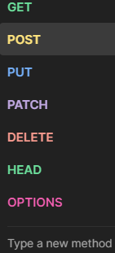
- WE ARE GONA DEAL WITH RESOURCE LIKE C.R.U.D
- C= POST = IT INDICATES CREATE SOMETHING IN SERVER.
- R= GET = TO GET THE CREATED INFORMATION .
- U = PUT /PATCH = TO MAKE MODIFICATION.
- D = DELETE =TO REMOVE.
- HTTP MEHTODS = POST , GET , PUT , PATCH , DELETE

WEB URL=
- UNIQUE ADRESS OF PARTICULAR SERVER /COMPUTER.

CONTENT TYPE=
- TYPE OF CONTENT XML , JSON , JS , HTML , TEXT.

COOKIES =
- ADDITIONAL INFORMATION.

FORM / ROW DATA =
- ANY DATA SENT BY THE CLIENT TO THE SERVER IS CALLED AS ROW / FORM DATA.

ACTUAL DATA [M]=
- THE SERVER SENDING THE RESPONSE.

STATUS CODE- INDICATIONS=
STATUS CODE | DESCRIPTION
100 | CONTINUE
200 | SERVER SUCCESFULLY HANDLED THE REQUEST.
300 | RE – DIRECTION REQUEST ( OTHER SERVER)
400 | CLIENT-SIDE ERROR
500 | SERVER -SIDE ERROR

LEVEL 200 (SUCCESS) | LEVEL 400(CONTINUE) | LEVEL (500)
200 : OK | 400 : BAD REQUEST | 500 : INTERNAL SERVER ERROR
201 : CREATED | 401 : UNAUTORIZED | 501 : NOT IMPLEMENTED
203 : NON AUTHORITATIVE INFO | 403 : FORBIDEN | 502 : BAD GATEWAY
204 : NO CONTENT | 404 : NOT FOUND | 503 : SERVICE UNAVAILABLE
 | 409 : CONFLICT | 504 : GATEWAY TIMEOUT  599 : NETWORK TIMEOUT

- RESPONSE TIME = TOTAL TIME TAKEN TO PROCESS AND SENT TO CALCULATE POST TIME , GET TIME , PUT/PATCH TIME / DELETE TIME BASED ON MILISECOND.
- RESPONSE TIME DECIDED BY SERVICE LEVEL ARGUMENT [ SLA].

PRE REQUSITES FOR API TESTING=
- ITS LIKE REQUIREMENTS BEFORE WE PERFORM SOMETHING ELSE
- 1 . KNOWLEDGE OF CLIENT – SERVER ARCHITECTURE .
- 2. KNOWLEDGE OF HTTP REQUEST AND HTTP RESPONSE PROPERTIES.
- 3. BASIC KNOWLEDGE OF DATA BASE.
- 4. CRUD OPERATIONS.
- 5 . KNOWLEDGE OF XML/JSON.
- 6. KNOWLEDGE OF API TESTING TOOLS.
- 7. API TEST CASES (+VE & -VE).
- 8. API DOCUMENT / API FUNCTIONAL SPEC / SWAGER DOCUMENT ( REQUIERMENT DOCUMENT).

POSTMAN=
API DEVELOPERS | API TESTERS
CREATE MOCK API | GUI
MONITOR API | OPEN SOURCE
DEBUGGING | EASY TO SEND REQUEST
CREATE API DOCUMENT | COLLECTION / BATCH RUNNER
SNIPPETS FOR VALIDATION
COMMANDLINE EXECUTION USING NEWMEN
CAN EASILY INTEGRATE WITH CI/CD TOOLS.

STEPS FOR USING POSTMAN=
- 1. CREATE A WORKSPACE . WORKSPACESCREATE WORKSPACEBLANCK WS NEXT.
- 2 . CREATE A COLLECTIOIN (+) ICON CREATE NEW COLLECTIONS BLANK -COLLECTIONCOLLECTION CREATE FOLDER CREATE REQUEST FOR FOLDER OR CREATE REQUEST DIRECTLY FOR COLLECTION.
- 3 . ADD A REQUEST .

- API DOCUMENT GIVEN BY BUSINESS ANALYST .
- FOR TESTERS IT IS GIVEN BY THE DEVELOPERS .
- BECOUSE THEY DESIGN API STATUS CODE , PAY LOAD , GIVEN BY DEVELOPERS.
- WE ARE GETTING URL IN THE API DOCUMENT.
EXAMPLE=
- SELLER WILL LOGIN TO AMAZON AND GIVES PRODUCT INFORMATION .
- IF THERE IS NO UI WE USE POSTMAN TO APPLOAD PRODUCT INFORMATION AND SERVER GIVES RESPONSE WITH THE HELP OF API NOT WITH THE HELP OF UI.

START=
- APPLICATION DOESN’T HAVE UI BUT BACKEND PART IS READY WE CAN DO API TESTING USING POSTMAN TOOLS.
- 1ST OPERATION IS TO CREATE USING POST HTTP METHOD OR ELSE WE WILL NOT GET, MODIFY , DELETE.
- CLICK ON SEND CONNECT TO SERVER PERFORM ACTION GIVE RESPONSE BACK.

- 204 =NO CONTENT – NO ACTUAL DATA / BODY.
- 404 = NOT FOUND -NOT USING PROPER URI.
- IN POSTMAN WE NEED TO SPECIFY PROTOCOL.
- REST API ARE IN THE FORM OF URI=URL + ENDPOINT

- 415 UNSUPPORTED MEDIA TYPE .
- NOT USING PROPER CONTENT / BODY WAS MISSING FOR POST METHOD.
- 200 OK = GET ,PUT CREATE .
- 201 COMPLETE = SENDING REQUEST WITH POST AND SUCCESS WE GET.

DELETE, GET
- EVERY TIME WE CREATE THERE WILL BE A UNIQUE ID GENERATED IN THE SERVER.
- TO CHECK IF ITS REALLY CREATED OR MODIFIED , DELETED WE USE GET OPERATION .
- FOR GET AND DELETE METHODS BODY IS NOT REQUIRED
- BECOUSE IT IS USED TO CHECK IF ITS ACTUALLY CREATED OR DELETED ,
- WE NEED TO PASS ID IN END POINT WHEN DELETE AND GET .

- 400 BAD REQUEST =SYNTACTIVAL ERROR , INPUT /MISTAKE IN BODY.
- 405 METHOD NOT ALLOWED = HTTP MEHTOD.
- PUT = COMPLETE UPDATION ,WE NEED TO PASS ENTIRE BODY FOR UPDATION,NO CREATE NEW ONE.
- PATCH = PARTIAL UPDATION , WE NEED TO PASS ONLY MODIFIED CODE INTO BODY.
- IF WE WANT TO PASS MULTIPLE QUERY STRING USE &.
- ?PAGE =2 & PAGE=5 (TO FILTER THE CONDITION)
- RESPONSE TIME ?DELAY =5 -5.1

COLLECTION=
- COLLECTION IS REPOSTIERY WHERE WE CAN CREATE MULTIPLE FOLDERS AND REQUEST DIRECTLY ADD REQUEST OR WE CAN HAD FROM FOLDER.

- WITH THE HELP OF SNIPPETS WE ARE DOING ASSERTION / VALIDATION.
- MANDETORY THINGS TO VERIFY IN RESPONSE =STATUS CODE AND ACTUAL DATA.

LOOSLY COUPLED=
- CHANGES HAPPENED IN APPLICATION WHICH IS NOT PART OF WEBSERVICES , WHICH IS NOT AFFECTING THE WEB SERVICES.

- GITHUB = ASSIGNING THE STORY TO DIFFERENT ORIGIN LIKE REG,LOG,HOME.
- BUILD VERSIONS SHOWS QUALITY OF DEVELOPERS.
- USING POSTMAN TOOL WE CAN CREATE REPOSITERY IN GIT HUB.
http://reqres.in /api/users ?page=2&page=5
resource end point parameters

WHAT TYPE OF APIS YOU HAVE TESTED=
- WE ARE DEALING WITH REST APIS.
- POSTMAN WEB SERVICE TOOL .
- SOME APPLICATION WILL GIVE READY MADE JSON BODY, WE NEED TO CREATE OUR OWN.

- 401 UNAUTHORIZED = NO PERMISSION TO PERFORM ACTION.
- DEFECT= NOT ACCORDING TO REQUIREMENT.
- ERROR = WE HAVE COMMITED MISTAKE.
- GIT HOME SCROLL BOTTOM API OR DOCU CLICK ON REST API (DEVELOPERS) AUTHENTICATION ANY END POINT .
- SCOROLL IN REST API DB CREATE REPO FOR AUTHENTICATED USER END POINT WE WILL GET.
- SCROLL TO BODY PARAMETER = HELP OF THIS CREATE JSON

AUTHORIZATION=
- BASIC OATH , BEARER TOKEN , OAUTH 1.0 , OAUTH 2.0 ETC……,
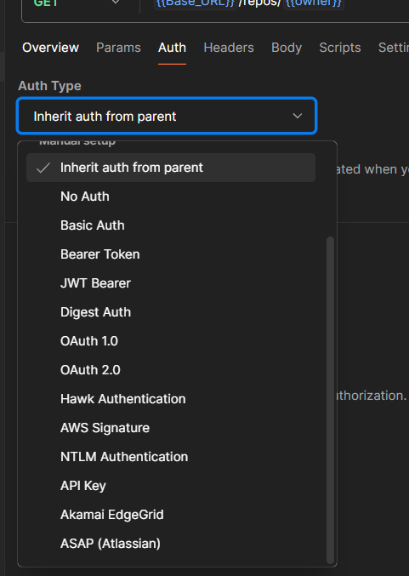
1 BASIC OAUTH = IT WILL ASK FOR UN AND PWD.
2. BEARER TOKEN =TOKEN (EXPIRY).
AUTHORIZATION BEARER TOKEN PASTE TOKEN.
SEND 201 POST (CREATED)
422 UNPROSSABLE ENTITY = UANBLE TO PRCESS DUE TO DUPLICATE DATA OR MANDETORY DATA NOT PRESENT IN BODY .
JSON CASE SENSITIVE.

API TEST CASES=
- IT IS A DOCUMENT WHICH CONSITS AF ALL POSIBLE SCENARIOS .
- PASSWORD ENCRYPTED (*****).
- TEMPLATE = HEADER AND BODY.
- EXAMPLE TC_ID= TC_APPLICATION_MODULE_TYPE OF TC_001.
- RESPONSE TIME WILL BE PRESENT IN = SERVICE LEVEL AGREMENT.
CTRL+D – PASTE ABOVE CELL , ALT+ENTER =MULTIPLE LINES , HOME- START ,END -TEXT END. MISSING ENVIRONMENT.
COLLECTION IS A MODULE IT INCLUDES FOLDERS AND REQUEST.
- RESPONSE TIME VARIOUS DUE TO INTERNET CONNECTION , SERVER POCESSING SPEED , CODE OPTIMIZATION.
- NOT DEFECT , PERFORMANCE ISSUE.
- (SEARCH ) INTERNET CONNECTION SPEED TEST.

HOT FIX/INCIDENT MANAGEMENT=
- DEFECT OCCURS IN PRODUCTION THEY NEED TO FIX IN COUPLE OF HOURS ,THEY NEED TO FIX BECOUSE (HIGHST PRIORITY) ENDUSERS ALREADY USING THE APPLICATION.
- BY FIXING ONE PARTICULAR FEATURE THEY MIGHT INTRODUCE ANOTHER DEFECT . IF ENTIRE APPLICATION GETS AFFECTED ENDUSERS GET WILL REDUCE.

PRE PRODUCTION ENVIRONMENT=
- PRE PRODUCTION AND PRODUCTION IS EXACTLY SAME CONFIGURATION , BUILD , FEATURES EVERYTHING IS SAME BUT PRE PRO ENVIRONMENT USED BY ORGANIZATION , PRODUCTION ENVIRONMENT END USERS USE.
- PRE PRODUCTION AND PRODUCTION SERVERS ARE IN COSTMER SIDE .
- DEV , TEST ENVIRONEMT SERVERS ON COMPANY SIDE .
- CUSTOMER IN US , COMPANY IN INDIA COME TO INDIA AND TEST NOT POSSIBLE.

- THEY WILL NOT TOUCH THE CODE IN PRODUCTION ENVIRONMENT .
- THEY WILL FIX THE CODE IN PRE PRODUCTION ENVIRONMENT ,WHEN IT IS WORKING FINE , THEY WILL REMOVE THE CODE FROM PRODUCTION AND ADD IT FROM PRE PRODUCTION ENVIRONMENT/ PATCH.
- ADV = NOT AFFECTING ANY OF THE CUSTOMERS.
APPLICATION IS NOT WORKING PROPERLY , IT GET HANGED IT IS NOT PROBLEM OF DEVICE ,UNINSTALL-INSTALL , RESTART ,AIRPLANE MODE ARE NOT THE SOLUTION -THE BACKEND IS SOMETHING HAPPENED ( PRODUCTION SERVER).

ENVIRONMENT URL TOKEN

- https://api.sklum.com/
- ---------------------------
- api/products
- api/categorys
- api/products/{productId}/vareints
- api/products/{productId}/varients/{varientId}
- api/discounts
- api/desocunts/{discountId}
- api/users/{userId}/adresses/{addressId}

- API TESTING ALREADY DONE IN TESTING ENVIRONMENT BUT MANAGER ALSO WANTS TO TEST IN DEVELOPER ENVIRONMENT SO HE SHOULD REPLACE THE URL EVERY WHERE IF THERE ARE 4000 REQUESTS ,
- AFTER THAT HE WANTS TO DO IN TESTING ENVIRONMENT REGRESSION TESTING ONCE AGAIN REPLACE 4000 REQUSTS.
- IN REAL PROJECTS WHERE THE TOKEN GET EXPIRED IN JUST 24HRS KEEP GENERATING NEW TOKEN IS NOT POSSIBLE FOR ALL REQUESTS.

SOLUTION=
- POSTMAN AS A FEATURE CALLED AS ENVIRONMENT .
- WE CREATE VARIABLES AND VALUES IN ENVIRONMENT .
- URL AND TOKENS KEEP CHANGING AGAIN AND AGAIN SO WE KEEP IN ENVIRONMENT FEATURE. ( CASE SENSITIVE).
- Variables= VARIABLES ARE THE PLACE HOLDERS FOR STORING DYNAMIC OR REUSABLE DATA THAT CAN BE USED ACROS REQUESTS , ENVIRONMENT AND COLLECTION.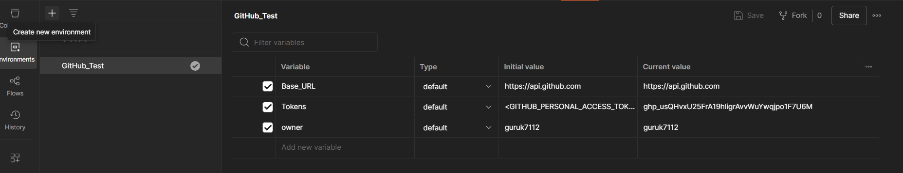
- DON’T FORGET TO SAVE AFTER ENVIRONMENT CREATION .
- INSTEAD OF HARDCODING WE ARE GOING TO CALL VARIABLE USING {{ (DOUBLE CURLY BRACES)
- EXAMPLE = {{ BASEURL}} /USER/REPOS , {{TOKEN}}

INITIAL VALUE =
- IF WE ARE EXPORTING THE FILES OR RUNNING ELSE WHERE INITIAL VALUES COMES INTO ACTION.
- If it’s empty not execute outside the postman

CURRENT VALUE=
- IF WE ARE DOING EXECUTION WITHIN POSTMAN ITSELF THEN CURRENT VALUE COMES INTO ACTION.
- WE WILL GET URL AND TOKEN IN API TESTCASES.
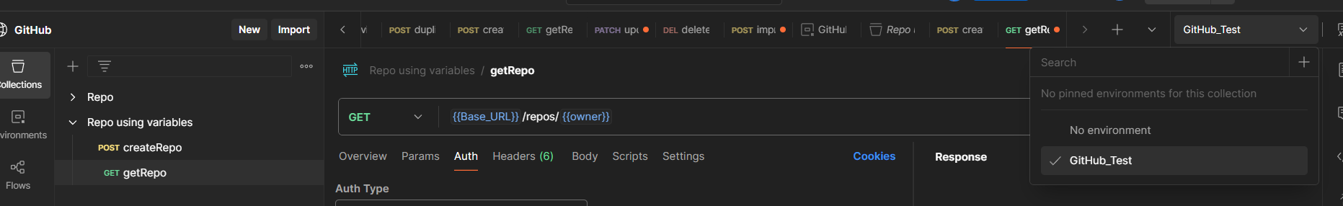

WHAT IS COMPLEX REQUESTS=
- IF REQUEST BODY CONSITS ARRAY [] , ARRAY OF OBJECT OR NESTED OBJECT IS CALLED AS COMPLEX REQUEST BODY .

WHAT IS SIMPLE REQUEST BODY=
- IF REQUST BODY NOT CONSITS ARRAY[] , ARRAY OF OBJECT OR NESTED OBJECT IS CALLED AS SIMPLE REQUEST BODY.

WHAT IS SWAGGER DOCUMENT OF API CONTRACT DOCUMENT OR API DOCUMENT=
- SWAGGER IS A TOOL WHICH IS USED TO CREATE API DOCUMENT.
- IT IS A DOCUMENT WHICH ACTS LIKE A CRS FOR BACKEND TESTING WHICH WILL BE INCLUDING ALL NECESSARIY , THIS FOR BACKEND TESTING LIKE URL , PAYLOAD / REQUEST BODY , CONTENT TYPE , MODELS & HTTP METHODS.
- IF REQUEST CONSITS MISTAKE BUT SERVER IS NOT WORKING BECOUSE IT IS NOT HITTING SERVER WE WILL GET 500 SERIES ERROR.

ENVIRONMENT=
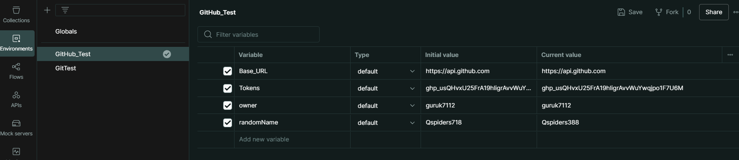
- EXAMPLE=
- EACH TEST CASE WE HAVE ATLEAST 5 CONDITIONS ,
- IF THERE ARE 4000TC 5*4=20000 VALIDATIONS IT IS POSIBLE BUT VAERY TEDIOUS JOB .
- THAT IS THE REASON WE GO INTO AUTOMATION .
- WE MAKE SURE THAT TOOL ITSELF DOES THE VALIDATION .
- LOOK TC AND TEST IN POSTMAN MANUEALLY ITS VERY TEDIOUS JOB.

- SOLUTION=body
- CLICK ON TEST OR SCRIPT .
- POSTMAN DESIGNED WITH THE HELP OF JAVA SCRIPT .
- FOR DOING POSTMAN CODING KNOWLEDGE IS NOT NEEDED .
- SO WE ARE GOING TO USE OF SNIPPETS THAT ARE ALREADY PRESENT IN POSTMAN.

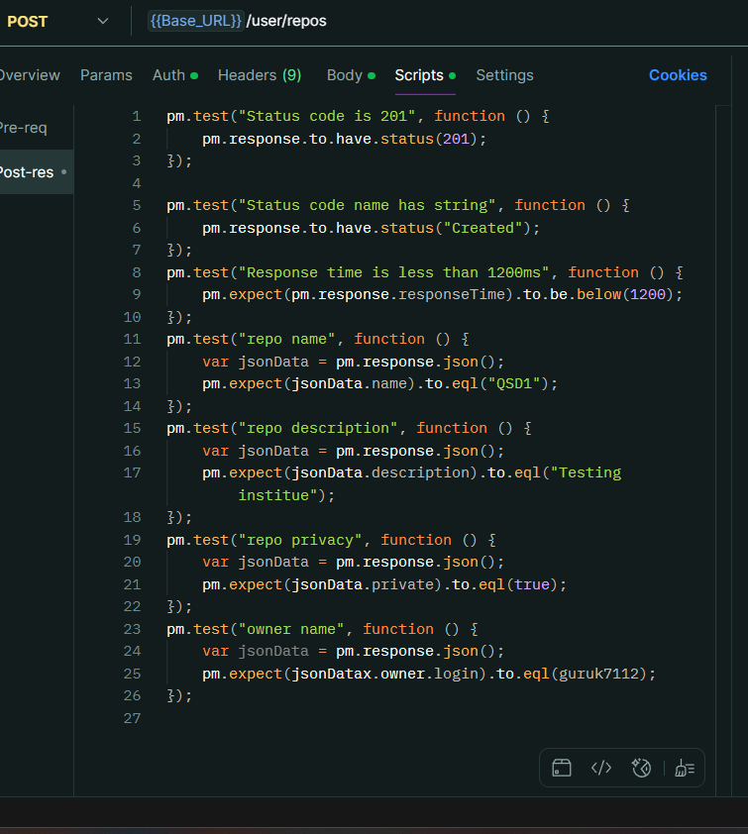
- STATUS CODE : CODE IS 200
USED TO SET THE STATUS CODE CONDITION.

2.STATUS CODE : CODE AS STRING

3.RESPONSE TIME LESS THEN 200

4.RESPONSE BODY JSON VALUE CHECK :
USED TO CHECK IF PRESENT IN RESPONSE BODY .

5.SNIPPETS
6. JSON PATH

STATUS CODE : CODE IS 200 400 BAD REQUEST 4.5ms
STATUS CODE : CODE NAME IS STRING
RESPONSE TIEM IS LESS THAN 200
- TO VALIDATE THE RESPONSE PARAMETER LIKE NAME,DESCCRIPTION , VALUE ETC.., WE NEED TO UNDERSTAND JSON PATH .
- JSON PATH SIMILAR TO XPATH.
- {  - "key1":"value1",  - "key2":"value2",  - "key3":{  - "key4":"value4",  - "key5":{  - "key6":"value6",  - "key7":{  - "key8":"value8",  - "key9":["abc","pqr","xyz"]  - }  - }  - }  - } | - .key1-----value1  - .key2-----value2  - .key3.key4-----value4  - .key3.key5.key6-----value6  - .key3.key5.key7.key8-----value8  - .key3.key5.key7.key9[1]-----pqr

- ALL OBJECTS CALLED AS ROOT OBJECT.
- USE ( . ) DOT OPERATOR TO GET INSIDE THE OBJECT
- Start from parent
- IT SHOULD COME FROM THE ROOT .
- IF THE VALUES ARE IN ARRAY WE NEED TO USE INDEXCES . START FROM 0

(Array of objects is also considered as indexes in JSON path)
(Object of array also considered as index)
(Ind vs inside index inside index is possible)

(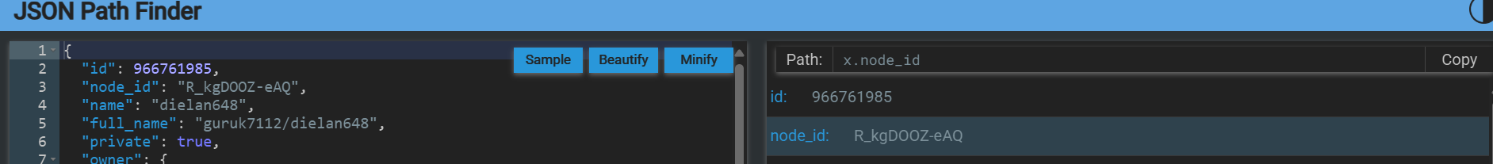
- SEARCH JSON PATH FINDE R- TO GET THE ACTUAL PATH .
- X IS NOTHING BUT JSON DATA.
- SNIPPETS = RESPONSE BODY : JSON VALUE CHECK WE ARE USING .

IN JSON WE HAVE PREREQUEST AND POSTRESPONSE=
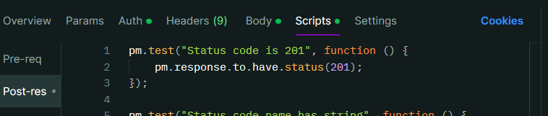
PRE CODITION (PRE REQUEST)= THOSE CONDITION THAT GETS EXECUTED BEFORE SENDING THE REQUEST .
- POST CONDITION(POST-RESPONSE) = THESE CONDITIONS WILL GET EXECUTED AFTER RECIVING THE RESPONSE.
- PRE CONDITION (PRE REQUEST) =WRITE JS CODE TO CHANGE THE NAMES .
- IN POSTMAN THERE IS NO INBUILT SNIPPETS TO GENERATE NAMES .
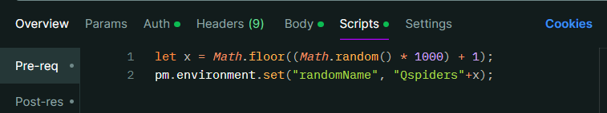
- SET ENVIRONMENT VARIABLE (SNIPPET) = IT IS GOING TO SET IN VARIABLE (CONCATE =STRING + X).
- EVEN IF THE NUMBER GETS CREATED THAT DOESN’T MAKE ANY PROBLEM BECOUSE WE ARE ALREADY DELETING THAT.
- INSIDE BODY ADD CURLY BRACESS {{ .
- DEL , PATCH , GET ARE DEPENDENT ON POST METHOD ALSO CALL JS CODE.

REQUEST CHAINING=
- PASSING THE OUTPUT OF 1 HTTP METHOD AS AN INPUT TO OTHER API.
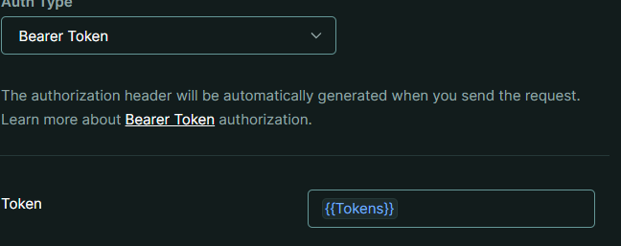
- BY CALLING THESE VARIABLES WE CAN EASYILY CHANGE THE URL AND PASSWORD.

- BY USING SAME VARIABLE FOR MULTIPLE HTTPS MEHTDOS IT IS CALLED AS REQUEST CHANING.

- FOR SECURITY ALSO WE HAVE USED VARIABLE.

TO CREATE NEW THING EVERY TIME WE ARE GOING USE CURLY BRACESS INSIDE A STRING ONLY IN BODY WE ARE GIVING STRING .
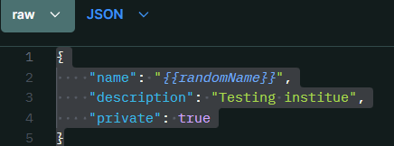
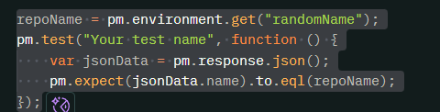

BATCH EXECUTION =
RIGHT CLICK ON COLLECTION RUN SELECT WHICH REQUIRED TO EXECUTE
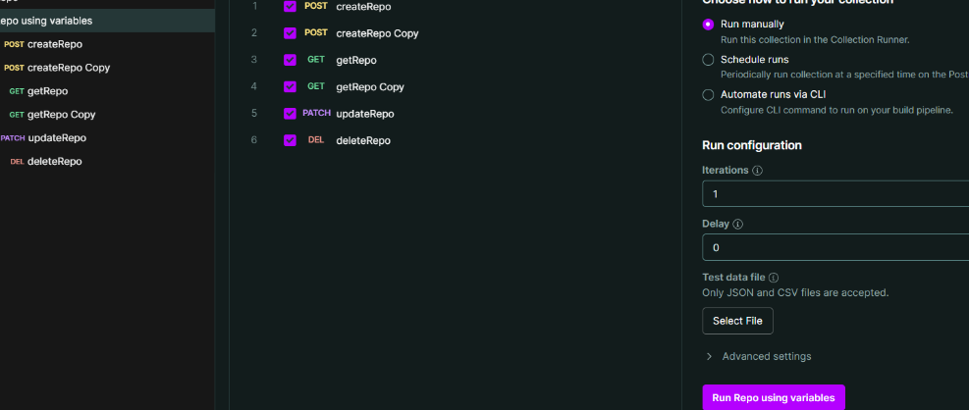
ITTERATION -HOW MANY TIMES NEED TO RUN .
DRAG AND DROP COLLECTION FROM SIDE BAR TO RUN.
DELAY TO STOP FOR THIS MANY SECONDS.

EXECUTION REPORT=
- GENERATING REPORTS USING NEWMAN , TO GENERATE IN COMMAND LINE WE NEED TO USE NEWMEN.
- INSTALL NODE JS CMD = 1 NODE -V , 2 NPM -V
- WE CAN DO EXECUTION IN POSTMAN AS WELL AS COMMAND LINE.
INSTALL NEWMEN CMD= npm install -g newman ( ignore all errors).
Newman -v
REPORT INSTALL CMD = npm install -g newman-reporter-html.

REPORT COLLECTION (…) MORE EXPORT
CMD = NEWMAN RUN FILEPATH -E OR -G ENVIRONMENT PATH ( TO RUN ALL THE REQUESTS )

IF THERE IS NO ENVIRONMENT IN CMD =
- ALL CONDITION FAIL BECOUSE IT TAKES ({{) VARIABLES WHICH CANNOT UNDERSTANDED BY THE CMD .
- SYNTAX = NEWMAN RUN FILEPATH -E ENVI PATH
- ENVIRONMENT AND COLLECTION ALL SHOULD BE EXPORTED FROM POSTMAN.
- TO GENERATE A REPORT
SYNTAX = NEWMAN RUN FILEPATH -E ENVI PATH -r html
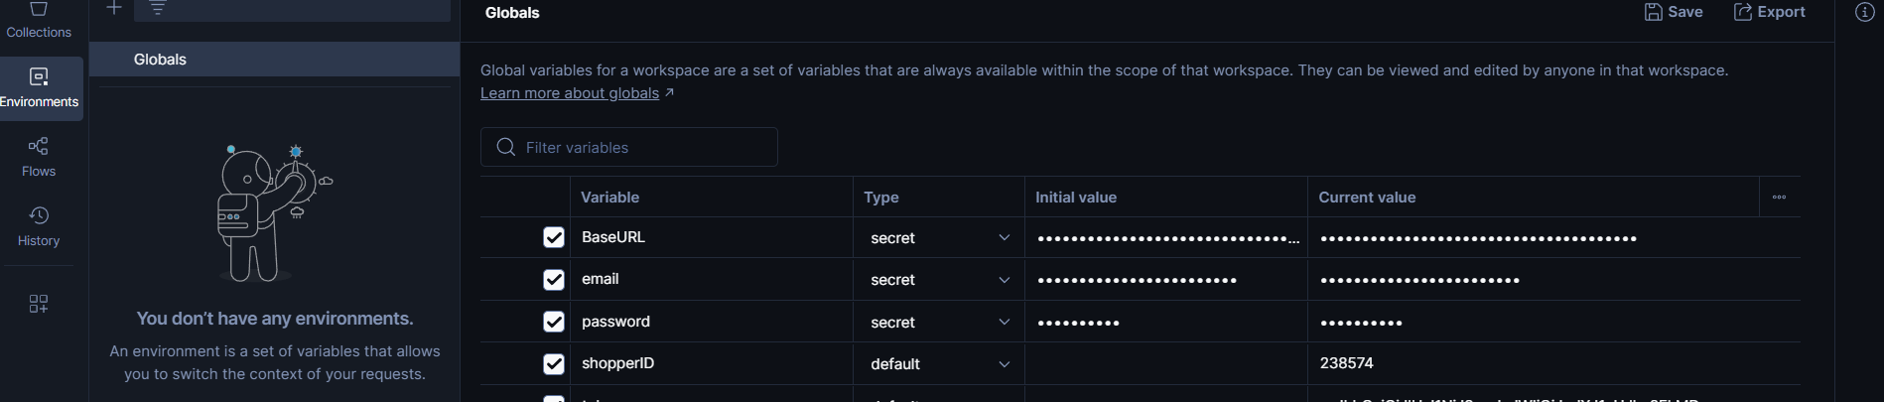
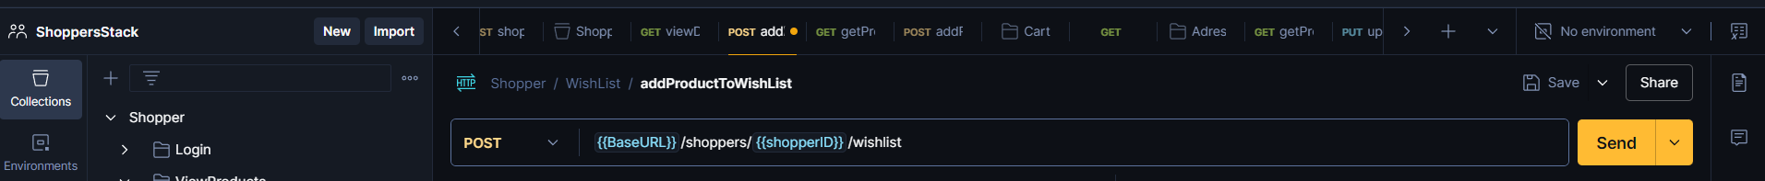
- ENVIRONMENT TYPE SECRET
- TO NOT SHOW THE VISIBILITY OF VALUES .
- IT IS GOING TO BE (Masking Character)
- BY CREATING GLOBAL ENVIRONMENT NOT TO SPECIFY ANY ENVIRONMENT IN COLLECTION.

TOKEN WE WILL BE GETTING IN THE BODY.
- EVERY TIME WE LOGIN TO APPLICATION WE WILL BE GETTING TOKENf.
- WE NEED 2 THINGS FROM THE RESPONSE
- 1 ANY ID 2 TOKEN.
- WE NEED TO KNOW THE EXPIRY OF THE TOKEN.(SHOPERSTACK 10 HRS)

EVERY TIME WE LOGIN THE TOKEN KEEPS ON UPDATING.
- WE ARE GOING TO CAPTURE FROM RESPONSE AND STORE IT AS A VARIABLE.
- WE CAN CAPTURE THE RESPONSE AND STORE IT AS A VARIABLE.
- JSON.parse (ITLL CONVERT 1 FORMAT TO ANOTHER FORMAT =JSON.parse(responseBody)).
- body=JSON.parse(responseBody)
- pm.globals.set("itemId",body.data[0].itemId);
- SET A GLOBAL VARIABLE(SNIPPETS) PASS VARIABLE KEY , VARIABLE VALUE .
- WHEN WE LOGIN USING POST IT IS GOING TO STORE IN ENVIRONMENT GLOBAL (LATEST TAKEN FROM RESPONSE DATA WILL BE CAPTURED).
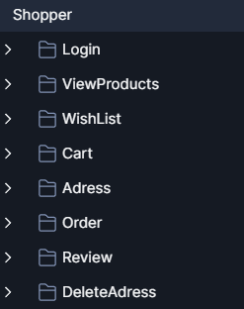
- 1 COMPLETE END TO END TEST CASE .

2.ON WISH LIST WE CAN DO ONLY 3 OPERATIONS THOSE ARE C.R.D

VIEW PRODUCT =EACH PRODUCT WILL HAVE SEPARATE PRODUCT ID = WE ARE GOING TO PASS THIS DYNAMIC BY USING SNIPPET =
SET GLOBLAL VARIABLE.

400 BAD REQUEST = ROW DATA ERROR.
403 FORBIDEN = WE NEED TO PASS THE TOKEN (AUTHORIZATION REQUIRED)
- IF CUSTOMER IS VERY PRECISE REGARDING THE RESPONSE TIME THEN WE TAKE INTO CONSIDERATION.
- OR AS PER THE INDUSTRIAL STANDARDS WE KEEP IN 1SECOND (1000ms).
DECLARING AUTORIZATION TO OWR COLLECTION OR FOLDER=
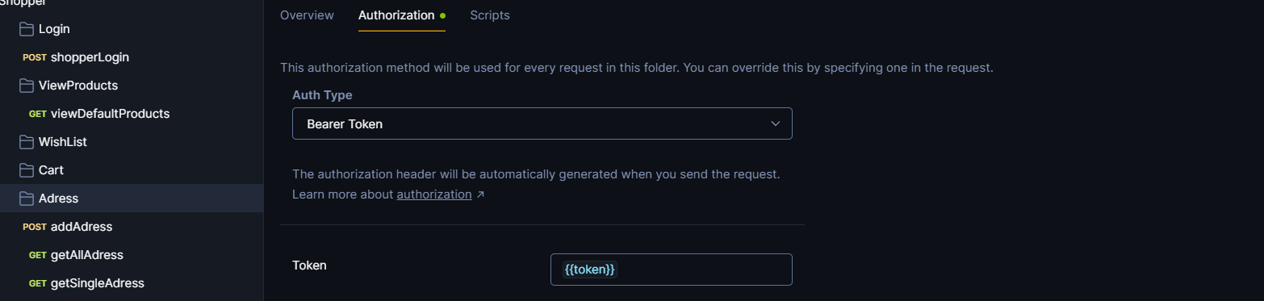
- WE CAN GIVE AUTHORIZATION FOR COLLECTION , FOLDERS THAT CAN APPLY TO REQUESTS.
- IF WE GIVE TO COLLECTION SOME FOLDERS OR REQEST MAY REQUIRE OTHER TOKEN SO ERROR.
- SO GIVE TOKEN FOR FOLDERS ( AUTHORIZATION IN FOLDER).

- EVERY TIME WE ADD A PRODUCT TO THE CART UNIQE ID WILL GET CREATED BY SERVER WE GET RESPONSE TIME .
- ALWAYS CAPTURE THE ID FROM POST(HTTP METHOD) MEHTOD .
- BECOSUE IN GET METHOD RESPONSE IN ARRAY FORMAT.

API ADV=
- AFTER UI GETS DEVELOPED WHATEVER API’S WE USED THE SAME API WILL BE INTEGRATED WITH THE UI , THEN WE GET RID OF POSTMAN.
- IN IT INDUSTRY THE COST IS INVERSLY PROPOTIONAL TO THE TIME .
- LESSER THE TIME MOST REVENUE WILL BE CREATED.

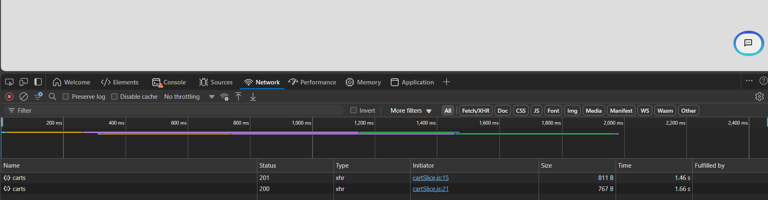
INSPECT=
- IN THE NETWORK TAB ALL THE API CALL MADE =REQUEST , RESPONSE , STATUS , TIMING ,PAYLOAD.
- AT THE LEFT END THERE ARE NAME RIGHT CLICK CLICK ON COPY COPY AS CURL(BASH) ADD IN POSTMAN ITLL GIVE ALL THE DETAILS.
- IF THE APPLICATION DOESN’T HAVE UI @ THE BACKEND WE NEED TO TEST IN POSTMAN.
- EXAMPLE =HOSPITAL APPLICATION ,TEST CUNSULTANT , WHICH TIME TO CONSULT , WHICH TYPE OF ILL.
- BOOK TICKET FROM LOCATION TO TO LOCATION.

PURPOSE OF DOING API TESTING / ADV=
- DOING API TESTING IN BUSINESS LAYER .
- WHAT EVER THE DEFECTS AVAILABLE FIND DEFECTS BRING IT TO NOTICE OF THE DEVELOPER.
- MAKE SURE THAT ALL THE DEFECTS ARE FIXED.
- MAKING THE APPLICATION STABLE EVEN BEFORE THE UI GETS DEVELOPED.
- IN THE INITIAL STAGE TRYING TO MAKE APPLICATION STABLE .
- OVERALL RELEASING THE APPLICATION SLIGTLY TIME WILL BE DECREASED.
- WHENEVER WE RISE A DEFECT TO THE DEVELOPER 1ST THING THEY DO IS THEY PERFORM API TESTING , IF API IS WORKING FINE THERE IS NO ISSUE WITH API.
- AND THERE IS A ISSUE WITH WEB DEVELOPER., HE MAY NOT DESIGN THE UI PROPERLY OR API IS NOT INTEGRATED WITH A UI PROPERLY.
- IN WEB SERVICE WE CANNOT SEE HOW THE REQUEST IS SENT IT IS COMPLETELY ABOUGHT BACKEND
- EXAMPLE= ICICI ATM -SBI CARD TRANSACTION (WE CANNOT SEE ).
- WE NEED TO DO API TESTING.
- DOING NEGATIVE TESTING IN API IS DIFFICULT BECOUSE TEXTFIELD CHARACTER LESSTHAN 1 API AND MORE THAN 1 API CREATING SOMANY API S IS DISADVANTAGE.

MISSALENIOUS=
- VARIABLES ARE 4 TYPES=
- VAULT = MOST SECURED.
- 1 LOCAL VARIABLE= SCOPE IS WITHIN THE REQUEST ONLY.
- 2 COLLECTION VARIABLE = SCOPE IS THROUGHT OF THE COLLECTION ONLY.
- 3 ENVIRONMENT VARIABLE = SCOPE IS THROUGHT OF THE ENVIRONMENT.(ENABLE MANUEALY)
- 4 GLOBAL VARIABLE = SCOPE IS THROUGHT THE WORKSPACE
- BY USING VARIABLE NAME BETWEEN THE DOUBLE CURLY BRACES WE CAN CALL THE VARIABLE.

- CREATING VARIABLES THROUGHT THE SNIPPETS PASS PERCENTAGE IS MORE.
- SELECT PORTION OF THE URI RIGHT CLICK CREATE VARIABLE.
- 3 WAYS OF CREATING VARIABLE =1 SNIPPETS , 2 ENVIRONMENTS , 3 SELECTING PORTION.
- { } SINGLE CURLY BRACES USED IN API DOCUMENT TO PASS PATH PARAMETER.(DYNAMIC DATA)

HOW TO HANDLE COMPLEX REQUEST=
- FOR COMPLEX REQUEST BY USING BINARY.
- SWAGER DOC COPY SAVE IT IN JSON EXTENSTION PASTE IT IN BINARY.
- BINARY PRESENT UNDER BODY WE NEED TO ADD JSON FILE.
- TO HANDLE SIMPLE REQUEST BODY FORM DATA OR ROW DATA.
- SIMPLE REQUEST ONLY KEY AND VALUE.

WHAT IS PAYLOAD=
- PAYLOAD IS THE REQUEST BODY WHERE WE ARE GOING TO PASS REQUEST TO THE SERVER USING POST ,PUT,PATCH.

WAYS OF POSTING THE REQUEST=
- USING ROW DATA SIMPLE REQUEST.
- USING BINARY COMPLEX REQUEST.
- USING FORM-DATA SIMPLE REQUEST.
- WE CAN UPLOAD IMAGES IN FORM DATA KEY SHOULD BE ALWAYS SMALL AND ENABLE THE FILE.
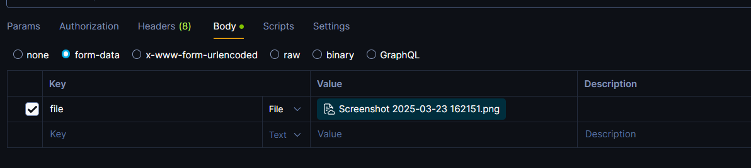

COMPLEX RESPONSE BODY=
- RESPONSE BODY CONSITS NESTED OBJECT , ARRAY OBJECT .

HOW TO HANDLE COMPLEX REQUEST BODY=
- WITH THE HELP OF JSON PATH WE CAN FIND COMPLEX RESPONSE BODY.
- REPLACE { , . , . IT IS USED TO GET INSIDE THE OBJECT , WHEN THERE ARE ARRAY USE INDEXING.

- CERTIFIACATION ERROR = GLOBE SYMBOL IN RESPONSE . SO USE IN CMD - -INSECURE.
- {{}} RED BRACES =VALUE ABSENT {{}} BLUE =VALUE PRESENT.

WHAT IS JSON PATH ? HOW TO HANDLE=
- IT IS TYPE OF XPATH TO FIND PARTICULAR KEY AND VALUE FOR THE PURPOSE OF VERIFICATION OR ASSERTION WHICH IS USED TO COMPLEX RESPONSE BODY.

- SAVE ALL THE JSON IN XLSX IN THE FORM OF CSV (COMMA DELIMATED) EXTENSION.
- AND AD BODY IN REQUEST ALL COLUMN NAME SHOULD BE THERE
- RUN COLLECTION ADD FILE SELECT FILE (CSV/JSON) RUN 201 CREATED.
- ALSO JSON FILE WE CAN DO . (WRONG FILE 400 BAD REQUEST).
- CREATE JSON DIRECTLY FROM ARRAY SAVE IT IN .JSON EXTENSION.
- ADD DOUBLE CURLY BRACES IN BODY REQUEST {RAW} WITH KEY .
- RUN ITTERATION BASED ON HOW MANY OBJECTS (3 IN BELOW) ADD JSON FILE CLICK ON RUN.
createdBy projectNamee status teamSize  me project1 Created 0  me1 project2 Created 0  me2 project3 Completed 0  XLSX TO CSV  BATCH EXECUTION CAN TAKE ONLY JSON AND CSV FILES | [  {  "createdBy": "abqc",  "projectNamee": "prwoject2",  "status": "Created",  "teamSize": 0  },  {  "createdBy": "abed",  "projectNamee": "prodject3", . JSON  "status": "Created",  "teamSize": 0  },  {  "createdBy": "acdd",  "projectNamee": "profject4",  "status": "Created",  "teamSize": 0  }  ] JSON

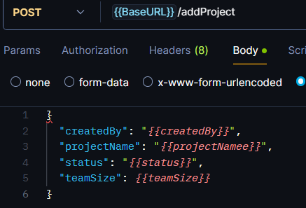 | 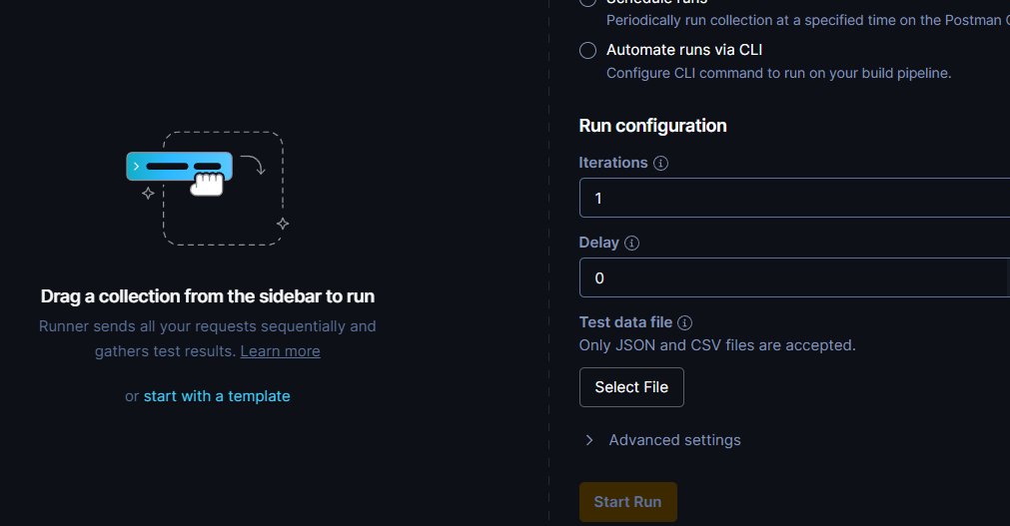

WHAT IS DATADRIVEN TESTING , WHY ITS REQUEIRED FOR WHICH TC YOU APPLLIED DATA DRIVEN TESTING IN POSTMAN .
- WE USED DATA DRIVEN TESTING FOR INSERTING PRODUCT IN ECOMMERCE APPLICATION.
- TO STORE THE DATA IN EXTERNAL RESOURCE , SO MODIFICATION AND MAINTANACE OF DATA WILL BE EASY , ASSERTION CAN BE DONE EASILY.

WHAT IS SWAGGER DOCUMENT OR API CONTRACT DOCUMENT OR API DOC=
- IT IS A DOCUMENT WHICH ACTS LIKE A CRS FOR BACKEND TESTING IT WILL BE HAVING ALL THE NCESSARY THINGS NEEDED FOR BACKEND LIKE BASE URL , REQUEST BODY , STATUS CODE , HTTP MEHTODS , ENDPOINTS. ETC…,

STAKC OF YOU APPLICATION =
- FE = HTML ,CSS,JS BE = JAVA , ORALE 11G.

WHAT IS REQEUST CAHNING AND WHY ITS NEEDED=
- OUTPUT OF THE ONE RESPONSE WILL BE USED FOR OTHER REQUEST BY CREATING VARIABLES WE CAN ACHIVE BATCH EXECUTION.
- IF HARDCODED MISTAKENLY DELETED ID , TOKEN THE BATCH EXECUTION WILL FAIL SO WE ARE USING REQUEST CHANING.

HOW TO PASS DYNAMIC VALUE TO THE REQUEST=
- BY GENERATING RANDOM VALUE IN PRE REQUEST WE CAN PASS DYNAMIC VALUE.

HOW TO HANDLE 400 SERIES REQUEST=
- CLIENT SIDE ERROR , SYNTACTICAL ERROR , CONFLICT , URI , UNAUTHORIZED , BAD REQUEST. BY FIXING.

TYPES OF PARAMETER=
- THERE ARE 3 TYPES OF PARAMETER=
- 1 PATH PARAMETER = IT IS USED TO SET RESOURCE PATH / END POINT MENTIONED IN SINGLE CURLY BRACES { } .
- 2 QUERY PARAMETER = PARAMS IN POSTMAN APPEND IN URI.
- FILTERING CRITERIA = PROVIDING CONDITION.
- 3 FORM PARAMETER = FILTER THE CONDITIOIN , ITLL COME IN THE APPEND BODY.

DIFFERENCE BETWEEN QUERY PARA AND FORM DATA=
QUERY PARAMETER | FORM-DATA
UPENDED IN URI | APENDED IN BODY
ANY ONE CAN SEE SECURITY LESS | NO ONE CAN SEE MORE SECURED.

STATUS CODE IN THE PROJECT.
400 BAD REQEST=
- ANY MISTAKE IN PASSING REQUEST BODY DATA , CONTENT TYPE.
- WHILE DOING DDT IF THE FILE IS NOT SAVED WITH .CSV WE WILL GET 400 BAD REQEUST.
401 UNAUTHORIZED=
- WHEN THERE IS MISTAKE IN USERNAME AND PASSWORD (BASIC AUTH).
- WHEN THERE IS A MISTAKE IN THE BEARER TOKEN OR TOKEN IS EXCHANGED OR EXPIRED.( DEVELOPER MIGHT HAVE CHANGED THE TOKEN).
- WHEN THERE IS MISTAKE IN CLIENT ID AND CLIET SECRET.
403 FORBIDDEN=
- NOT A AUTHORIZED PERSON TO MAKE USE OF PARTICULAR API.
- INSTEAD OF USING HTTP PROTOCOL IF WE ARE USING SMTP OR FTP.
404 NOT FOUND=
- WHEN THERE IS A MISTAKE IN THE ENDPOINT OR URI .
- INSTEAD OF USING HTTP WE USE HTTPS.
- WHEN YOU WANT TO AXCESS THE DELETED RESOURCE YOU WILL GET 404 NOT FOUND.
405 METHOD NOT ALLOWED=
- WRONG HTTP METHOD WE WILL GET MEHTOD NOT FOUND ERROR.
409 CONFLICT=
- BECOUSE OF DUPLICATED DATA IF COMPONENT NOT ACCEPTED.
422 UNPROCESSABLE ENTITY=
- BECOUSE OF DUPLICATE IT CANNOT PROCESS.
- 409 OR 422 BASED ON API DOCUMENT.
415 UNSUPORTED MEDIA TYPE=
- IF GIVING PUT / PATCH AND POST MEHTOD NOT PROVIDING THE BODY.
- FOR POST ,PUT, PATH BUT CONTENT TYPE MISS MATCH.
429 TOO MANY REQUEST=
- SENDING MULTIPLE REQUEST AT A TIME.
206 PARTIAL CONTENT=
- REQEUST FOR A RESOURCE HAS BEEN SUCCEFULLY BUT ONLY PARTIAL CONTENT IS RECIVED.
406 NOT ACCEPTABLE=
- THIS OCCURS WHEN THE CLIENTS REQUEST SPECIFYS IT CAN ONLY ACCEPT DATA IN CERTAIN FORMATS. (PDF , TXT , DOC ) BUT THE SERVER CANNOT PROVIDE DATA IN ANY OF THIS FORMATS.
DIFF = 200 PUT PATH GET 202ACCETPTED.
WHEN A USER SUBMITS A FORM THE SERVER ACCEPTS THE REQUEST BUT NEEDS TO PRESS THE DATA IN THE BACKGROUND IN THIS CASE THE SERVER WRITTENS 202 INDICATES THAT REQEST HAS BEEN ACCEPTED THE PROCESSING IS NOT YET COMPLETED.
- FOR EVERY MODULE THEY NOT CREATE API LIKE HELP , T&C.
- MAINLY CRITICAL FEATURES

500 SERIES=
500 INTERNAL SERVER ERROR=
- WHEN THERE IS A PROBLEM IN THE SERVER DUE TO MORE NUMBER OF LOAD.
- THE RESOURCE MIGHT BE DELETED.
- THE SERVER IS UNDER MAINTANACE.
- WHEN DEVOPS UPLOAD NEW RESOURCE TO SERVER WE WILL GET 500 SERIES.
502 BAD GATEWAY=
- DUE TO OVERLOADED COOKIES AND CACHE.
504 GATEWAY TIMEOUT=
- WHEN WE ARE NOT ENTERING THE DATA WITHIN A PARTICULAR PERIOD OF TIME EX =OTP.
599 NETWORK TIMEOUT=
- BECOUSE OF SLOW INTERNET.

ROLES AND RESPONSIBILITYS REGARDING POSTMAN=
- ANALYZING THE SWAGGER DOCUMENT.
- WRITING THE TEST CASE .
- BATCH EXECUTION.
- INVOLVED IN GENERATING REPORTS.
- INVLOVED IN VALIDATION USING SNNIPETS.
- POSTING A REQUEST IN DIFFERENT WAYS RAW , BINARY , FORM-DATA.
- HANDLING REQUEST CHANING.
- DDT INVOLVED .
- C.R.U.D OPERATION.
- HANDLING BEARER TOKEN.
- INVOLVED IN WRITING JSON PATH IN COMPLEX REQEUST BODY.
- HANDLING PARAMETER , PATH , QUERY , FORM.

CHALLENGES FACED AS API TESTER=
- FINDING JSON PATH IN COMPLEX RESPONSE.
- INITIALLY UNDERSTANDING SWAGGER DOCUMENT.
- IF TEST CASE WERER NOT CLEAR.
- AUTHENTICATION TOKENS WERE FREQUENTLY CHANGED. DEVELOPERS CHANGED NOT INFORMING.

HOW TO HANDLE 500 SERIES =
- NETWORK TAB WHEN UI IS DEVELOPED.
- IF KEY IN LOWER CASE WE GET 500.
- TO CHECK IF IT IS A CLIENT SIDE /SERVER SIDE ERROR WE HAVE USED API DEBUGGING TOOL ( FIDLER ANY ONE CHARLES PROXY ) TO CHECK ERROR FROM CLIENT SIED OR SRVER SIDE .
- IT IS GOING TO PROVIDE 200,400 REQUEST.

PROJECT RELATED DEFECTS IN BACKEND=

XML PROLOG=
- IT IS A OPTIONAL INFORMATION IN XML FILE BUT IF IT IS PRESENT THEN IT SHOULD BE IN 1ST LINE OF XML FILE.

WHAT PC DATA=
- PARSED CHARACTER DATA VALUE PRESENT BETWEEN OPEN AND CLOSE XML TAGS IS CALLED AS PC DATA.
- IT IS A TECHNICAL TERM FOR DATA.

SCHEMA=
- THE RULES THAT ARE PROVIDED OR SET BY SERVICE PROVIDER IS KNOWN AS SCHEMA.

AUTHORIZATION AND AUTHENTICATION=
- AUTHENTICATION =LOGIN WITH USER NAME AND PASSWORD , ALWAYS COMES FIRST.(403)
- AUTHORIZATION = HAPPENS AFTER AUTHENTICATION , PROVIDING ACCES CONTROL.
- BEARER , BASIC TOKEN , AUTH1.0 , AUTH 2.0
AUTHENTICATION | AUTHORIZATION
- VERIFY WHO YOU ARE . | - VERIFYS WHAT YOU ARE ALLOWED TO DO
- NEED TO ENTER UN , PWD, OR TOKEN OR OTP | - TO CHECK AUHTNTICATED USER HAS ACCESS TO THE REQUEST RESOURCE.
- HAPPENS BEFORE = AUTHORIZATION | - HAPPENS AFTER =AUTHENTICATION/.
- IF AUTHENTICATION FAILS , YOU GET 401 UNAUTHORIZED. | - IF AUTHRIZATION FAILS , YOU GET 403 FORBIDDEN.
- LOGGING IN USING YOUR EMAIL AND PASSWORD. | - EX= A LOGGED IN USER TRYING TO ACCESS THE ADMIN DASHBOARD.

BASIC AUTH=
- IT INCLUDES USER NAME AND PASSWORD THERE IS NO EXPIRY , IT IS READABLE ANY ONE CAN SEE.
ANY ONE ONLY

BEARER TOKEN=
- GIVEN BY DEVELOPER OR HE GIVES ENDPOINT TO GET THE TOKEN .
- TOKEN IS LEANGTHY NON READABLE WE CANNOT REMEMBER SO TOKEN EXPIRY IS 15 TO 20 DAYS GIVEN BY DEVELOPER
- OR 12HRS EXPIRY DEVELOPERS GIVE ENDPOINT TO GET TOKEN.

AUTH 2.0 =
- PROVIDED BY DEVELOPER BY USING CLIENT ID , CLIENT SECRET , AUTHORIZATION URL WE CAN GENERATE TOKEN.
- THIS TOKEN EXPIRES IN 20 MINUTES .
- IT WORKS LIKE OTP , IT IS WIDELY USED.

AUTH 1.0 =
- IT IS MOST SECURED BUT IT IS MORE COMPLEX SO IT IS LESS PREFERED.
- IT PROVIDE 2 LEVELS OF SECURITY.
- 1 CLIENT ID , CLIENT SECRET , AUTHORIZATION URL , ACCESS ID , AXCESS SECRET ,THEN IT IS GOING TO CREATE TOKEN.

WHICH MEHTODS ARE KNOWN AS SAFE MEHTODS=
- GET METHOD= BECOUSE IT IS NOT MODIFING IN THE SERVER POST CREATING IN SERVER , PUT/PATCH MODIFING IN SERVER, DELETE REMOVE FROM DATABASE SERVER.

INDEMPOTENT METHODS=
- INDEMPOTENT METHODS ARE GET, PUT AND DELETE .
- SEVERAL TIME WE WILL GET SAME RESPONSE BODY.

NON INDEMPOTENT METHODS=
- NON INDEMPOTENT METHODS ARE POST AND PATCH=
- WE WILL GET DIFFERENT RESPONSE BODY.

DIFFERENCE BETWEEN COOKIES AND CACHE=
- AUTOMATIC EXPIRY COOKIES .
- COMPANIES GOING TO USE DATA COOKIES.
- CACHE MANUALLY EXPIRE.
- USES SOME MAMORY IN SYSTEM CACHE.

HOW YOU VERIFY YOUR API USING FRONTEND=(defect in front end)
- IN THE NETWORK TAB WHEN INSPECT WE WILL GET WE CAN SEE PAYLOAD , STATUS CODE , RESPONSE TIME.
WITH THE HELP OF COOKIES WE ARE GOING TO PASS ADDITIONAL DATA .
NETWORK ACTION DONAME RIGHT CLICK COPY COPY AS CURL(BASH) - COPY PASTE IN POSTMAN GET METHOD.
PARAMS ARE USED TO SEND QUERY STRING TO APPEND IN URI.
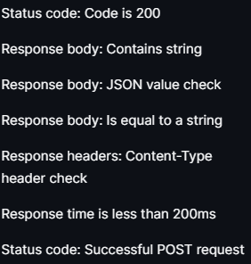 | 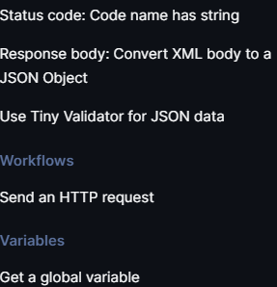

Schedule run in batch runner.
curl stands for Client URL and is a command-line tool used to transfer data to or from a server using various protocols.
• Supports many protocols:
HTTP, HTTPS, FTP, SFTP, SMTP, LDAP, etc.
• Allows GET, POST, PUT, DELETE, etc. requests.
• Works across platforms (Linux, Windows, macOS).
• Often used in API testing, automation, file transfers, etc.

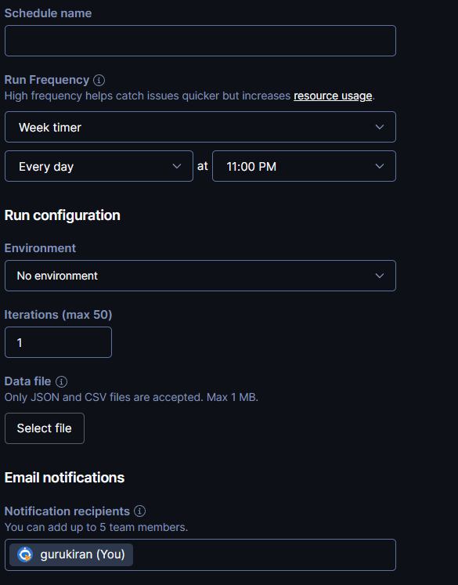

• 100 Continue  • 101 Switching Protocols  • 102 Processing (WebDAV)  • 103 Early Hints | • 200 OK  • 201 Created  • 202 Accepted  • 203 Non-Authoritative Information  • 204 No Content  • 205 Reset Content  • 206 Partial Content  • 208 Already Reported (WebDAV) | • 300 Multiple Choices  • 301 Moved Permanently  ")  • 303 See Other  • 306 (Unused)  • 307 Temporary Redirect  • 308 Permanent Redirect | • 400 Bad Request  • 401 Unauthorized  • 402 Payment Required (Rarely used)  • 403 Forbidden  • 404 Not Found  • 405 Method Not Allowed  • 406 Not Acceptable  • 407 Proxy Authentication Required  • 408 Request Timeout  • 409 Conflict  • 410 Gone  • 411 Length Required  • 412 Precondition Failed  • 413 Payload Too Large  • 414 URI Too Long  • 415 Unsupported Media Type | - 422 Unprocessable Entity (WebDAV)  - 423 Locked (WebDAV)  - 424 Failed Dependency (WebDAV)  - 425 Too Early  - 426 Upgrade Required  - 428 Precondition Required  - 429 Too Many Requests  - 431 Request Header Fields Too Large  - 451 Unavailable For Legal Reasons | • 500 Internal Server Error  • 501 Not Implemented  • 502 Bad Gateway  • 503 Service Unavailable  • 504 Gateway Timeout  • 505 HTTP Version Not Supported  • 506 Variant Also Negotiates  • 507 Insufficient Storage (WebDAV)  • 508 Loop Detected (WebDAV)  • 510 Not Extended  • 511 Network Authentication Required

Point | 401 Unauthorized | 403 Forbidden
🔐 Authentication | ❌ Missing or invalid credentials | ✅ Credentials are valid
🆔 Identity | ❓ Server doesn’t know who you are | ✅ Server knows who you are
🚪 Access Blocked | 🔒 Need to log in or re-authenticate | ⛔ Logged in, but not allowed to access
🛠️ Fix | ✅ Log in or send correct token | ❌ Only admin can grant access or change role
Point | Authentication | Authorization
🔐 means | Confirms who you are | Confirms what you can do
🪪 Purpose | Verifies identity (login, token, etc.) | Verifies permissions (access rights)
✅ Happens When? | Comes before authorization | Happens after authentication
🎯 Example | Entering username & password | Accessing admin page after login

Workspace → Whole Project

Collection → Module (Test Suite)

Folder → Sub-Module

Request → Individual Test Case

Tests (in Postman) → Assertions
402 payment required=
user triees ot make a purchase without making payment.

410 gone=
permenently deleted from the server , resource gone forever.

429 to many requests=
sending too many login attemts in a short time ,single client or has enforced a rate limiting policy.

501 not implemented=
The server recognizes the request method, but does not support it for the requested resource.

503 service unavailable=
The server is temporarily unable to process the request.
let randomNumber = Math.floor(Math.random() * 9000) + 1000;
pm.environment.set("rNumber", randomNumber);

"email": "linka123{{rNumber}}@gmail.com",
"firstName": "puneee{{rNumber}}", direcltly concat

//status code: code is 200
pm.test("Status code is 201", function () {
pm.response.to.have.status(201);
});

//responsebody contains string
//var data=JSON.parse(responseBody); or any one we can use
var jsonData=pm.response.json();
pm.test("Body matches string", function () {
pm.expect(data.id).to.include(45);
});

//responsebody json value
pm.test("Your test name", function () {
var jsonData = pm.response.json();
pm.expect(jsonData.value).to.eql(100);
});

//response time is less then 200ms
pm.test("Response time is less than 200ms", function () {
pm.expect(pm.response.responseTime).to.be.below(2000);
});

//statuscode successfull post request
pm.test("Successful POST request", function () {
pm.expect(pm.response.code).to.be.oneOf([201, 202]);
});

pm.test("Successful response", function () {
pm.expect(pm.response.code).to.be.oneOf([200, 201, 202]);
});

//status code: code name as String
pm.test("Status code name has string", function () {
pm.response.to.have.status("Created");
});

Why the $ is important:
- Standard Variables {{variableName}}: These refer to variables you created (in Environment, Global, or Collection scopes).
- Dynamic Variables {{$variableName}}: These refer to variables Postman created. They generate a new, random value every single time you hit the "Send" button.
Variable | Result
{{$randomBoolean}} | A random true or false.
{{$randomInt}} | A random number between 0 and 1000.
{{$guid}} | A unique 36-character ID.
{{$randomEmail}} | A fake email address (e.g., test@example.com).
{{$timestamp}} | The current time in Unix format.

Popular String Dynamic Variables
Here are the ones you'll use most often in your JSON bodies:
Variable | Example Output | Best Use Case
{{$randomFullName}} | "Jane Doe" | User profiles
{{$randomEmail}} | "albert_92@gmail.com" | Registration forms
{{$randomPassword}} | "aB1@skldfj" | Security testing
{{$randomJobTitle}} | "Lead Solutions Architect" | Employee data
{{$randomCity}} | "New York" | Address fields
{{$randomUUID}} | "f47ac10b-58cc..." | Unique transaction IDs

